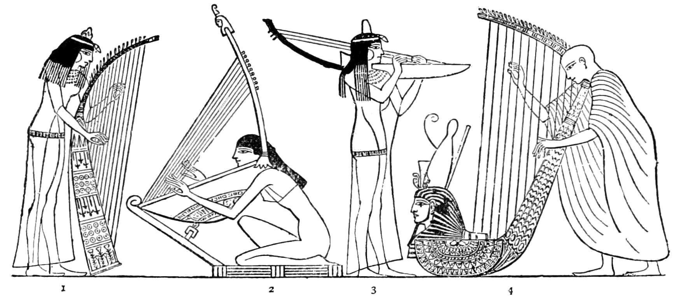

Ancient Egyptian Musical Instruments
What different types of instruments did the Ancient Egyptian’s use?
1.
2.
3.
4.

How were they made?

Design Criteria
My design must:
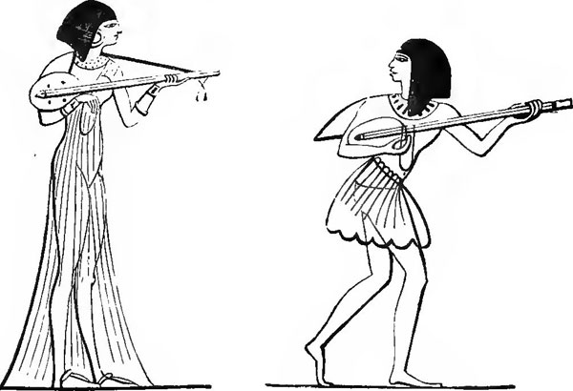
1.
2.
3.

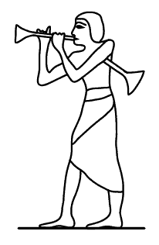
Potential Designs
Design One | Design Two
Design Three | Design Four
Chosen Design

List of materials that I need:

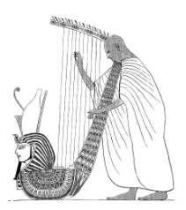
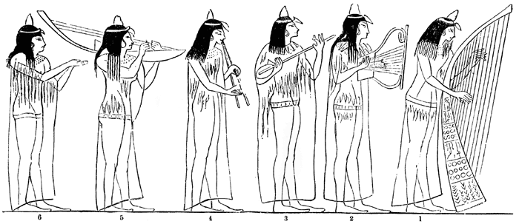
Evaluation

- Did your finished piece look exactly as you had planned? YES/NO
Why?

- What two things are you pleased about your finished project?

- If you could do this again what would you change?

- Now get a friend to look at your project.
What do they like about your Egyptian instrument and why?
Write it below

