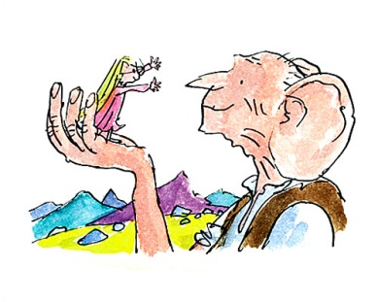

Geography

* Maps – Give children a list of countries the Giants gobble up children from. Use atlases to locate these.

Literacy

* Instructions – How to Collect Dreams
* Postcard/Recount – Sophie at Buckingham Palace
* Poem - Recipes for dreams
* Acronyms – BFG
* Similes – Describing giants
* Silly Words – Glossary/Definitions – Create definitions and then look in text to see if they are correct.
* Draw what you hear using film clips/description from the book. (BFG Text Excerpt)
* Create a missing poster for Sophie.
* Character descriptions
* Giant spotted! – write an eyewitness account
* Describe your own dream jar
* Setting – Using chapter 1, find phrases that describe the setting

PSHE

* Bullying – What is a bully? What is bullying? How to be a good friend.
* Dreams – Dreams we have at night and dreams we might have for the future.
* Peace – ‘Human beans is killing each other much quicker than giants is doing it.’ How can we promote peace?

Art

* Design a friend for BFG
* Design an evil Giant to join the human eating gang
* Looking at Quentin Blake’s illustrations – drawing ourselves as a character.
* Decorate a dream jar with dreams for the future.
* Design a new instrument for the BFG to use as his has broken.

Maths

* Maps – How fast can BFG travel?
* Area of a footstep – drawing on squared paper, comparing arm spans, etc. measurements to each other/BFG’s.
* Measuring different heights – Does the tallest person have the longest arm span?
* Problem Solving – Dream Bottles – How many different dreams can be made?
* Data – BFG can only eat Snozzcumbers which is a type of fruit/vegetable. What are our favourite fruits or vegetables? Create pictogram/bar charts.

Science

* How do we hear? How does the Giant hear?
* How do the bubbles get into our drinks?
* Why do the bubbles go down instead of up in BFG?
* Do all bubbles travel up? Design an experiment to test.

**The BFG**