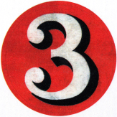**Ch, Sh, Th or Wh**

1. I like to eat _____ips with my _____icken.
2. Don’t ru ______ _____rough here. You might fall over.

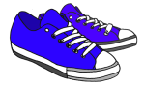

1. ____ere are your _____oes? You can’t go barefoot.



1. _____ich witch _____ould cast the spell?
2. We always order ______inese food for lun____ on Fridays.
3. I need to ex____ange my books at the library.
4. ____en we go ____opping, ___all we buy a _____istle?
5. ______ildren who are ____y are often very quiet.

9. I broke my _____umb _____en my brother ______rew a ball at me!

10._____ere are _____ree ____ings I would wi___ for.

**‘wh words:** ____ere ____en ____ich ____y ____o

**‘th’ words:** ____at ____ere ____en ____ey ___em ___is

**‘ch’ words:**  ___ance ___ange ___ildren whi___ bun____

**‘sh’ words:**  wi____ wa___ing sma___ ___opping ___ine