Floppy’s Phonics (2A) The Red Coat

Word List

Read the words to your teacher.

|  |  |  |  |
| --- | --- | --- | --- |
| red | coat | king | Chip |
| said | bed | load | put |
| sing | will | soak | hip |
| shop | goat | dip | fed |
| tip | nip | wing | smell |
| bit | led | load | sip |
| pip | big | rip | odd |
| zip | soap | ring | foam |
| washing | look | upset | fits |

C:\Users\Eve\AppData\Local\Microsoft\Windows\Temporary Internet Files\Content.IE5\39XIXXBW\MC900098039[1].wmf

Well done!!!

Tricky words

king ________________ _________________ ________________

coat ________________ _________________ ________________

smells ________________ _________________ ________________

odd ________________ _________________ ________________

foam ________________ _________________ ________________

soak ________________ _________________ ________________

load ________________ _________________ ________________

look ________________ _________________ ________________

When you have read the words three times to your teacher you can colour in the box.

|  |  |  |  |
| --- | --- | --- | --- |
| king |  |  |  |
| coat |  |  |  |
| smells |  |  |  |
| odd |  |  |  |
| foam |  |  |  |
| soak |  |  |  |
| load |  |  |  |
| look |  |  |  |

Sounds to think about:

oa

Say and write the words;

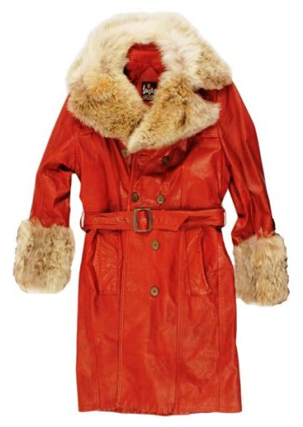

coat ______ ______ ______

C:\Users\Eve\AppData\Local\Microsoft\Windows\Temporary Internet Files\Content.IE5\XJMLSG5P\MC900412642[1].wmf soap ______ ______ ______

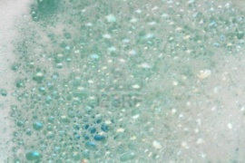 foam ______ ______ ______

C:\Users\Eve\AppData\Local\Microsoft\Windows\Temporary Internet Files\Content.IE5\XJMLSG5P\MC900324454[1].wmf goat ______ ______ ______

C:\Users\Eve\AppData\Local\Microsoft\Windows\Temporary Internet Files\Content.IE5\CV247V3K\MM900286789[1].gif boat ______ ______ ______

Pages 1-5

Look at the pictures.

What is Chip? Chip is a ________.

What does he need? He needs a ______ ________.

Where did they go? Mum took Chip to a _______.

What did Chip put on? Chip put on a ____ _____.

Draw the picture of Chip on page 5.

Pages 4-7

Put the story in order.

|  |
| --- |
|  |
|  |
|  |
|  |

|  |
| --- |
| The coat had an odd smell. |
| Mum took Chip to a shop. |
| “Yuk. It smells odd,” said Chip. |
| Chip put on the red coat. |

Who said it?

A red coat.

Page 3

_________________

Will this coat do?

Page 4

____________________

Page 10

I’ll put this load on.

____________________

Page 16 “He is the red king,” said ___________

Choose the correct word.

Page 9 It can ______ in the tub. soak / soap

Page 11 Chip put the ________ in. boat / coat

Page 12 Dad’s washing was ________ yellow / red

Page 14 Chip was _______ upstairs / upset

Pages 6 and 7

It _____ .

Draw the picture and label it.

Mum Chip Kipper Biff Wilf Wilma Floppy

Pages 8 and 9

Unscramble the sentences.

put Chip coat the tub. in the

soak the tub. It can in

What foam. of lot a

What did Chip say? What did Wilma say?

Pages 11 – 15

|  |
| --- |
|  |
|  |
|  |
|  |

|  |
| --- |
| “But look at the coat,” said Mum. |
| Dad’s washing was red. |
| Chip put the coat in. |
| “Look at my washing,” said Dad. |

Look at pictures. Who was it?

Yes or No?

**Chip** was a king. ________

Mum took **Biff** to a shop. ________

**Wilma** put the coat in the tub. ________

**Dad** had a load of washing. ____________

**Wilf** put the coat in. _________

**Kipper** was upset. ___________

Draw Chip as the red king.

“He is the red king,” said Mum.