Dear Neilly Beag
We are having a nice time visiting Loch Ness. Grannie Island and I looked for Nessie. It was fun. We didn’t find her. See you soon.
Love, Katie

Dear Neilly Beag Having a wonderful time exploring Loch Ness. The loch is HUGE. I think it’s the size of Struay! Grannie Island and I have searched for Nessie all week. I fell in the loch chasing after her but it was only a shadow. I was as wet as a sheep on dipping day. Grannie couldn’t stop laughing! Haven’t found Nessie yet but I’m NOT giving up! Remember to walk Bob every day and feed the cats. Love, Katie

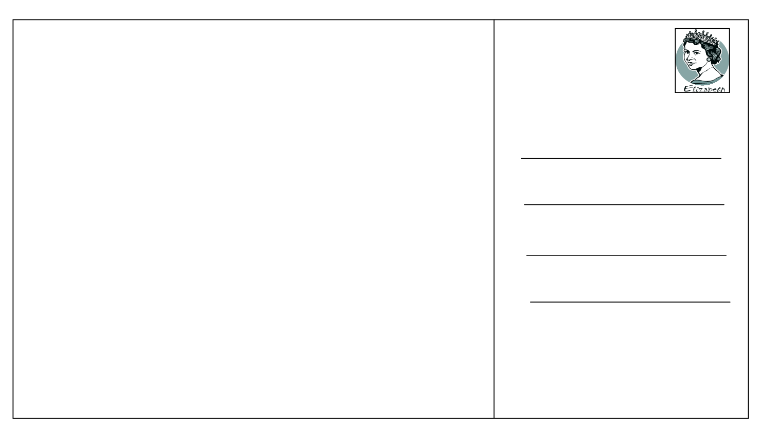
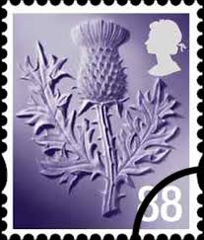
I can plan and write the first draft of a postcard from Katie Morag 12.3.15

Neilly Beag
3 High Street
Isle of Struay
PA 78

I can write a postcard from Katie Morag 13.3.15
Dear Neilly Beag ___________________________________________________________________________________________________________________________________________ Love, Katie
I can write a postcard from Katie Morag 13.3.15
Dear Neilly Beag _________________________________________________________________________________________________________________________________________________________________________________________________________________________________________________ Love, Katie

