**Letter ‘s’** Name ________________

Write the letter ‘s’ below.

Now have a go yourself.

______________________________________________

Which of these pictures start with an ‘s’?

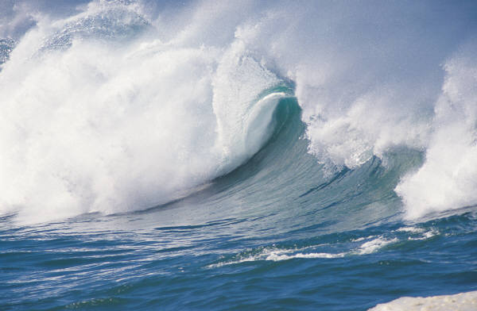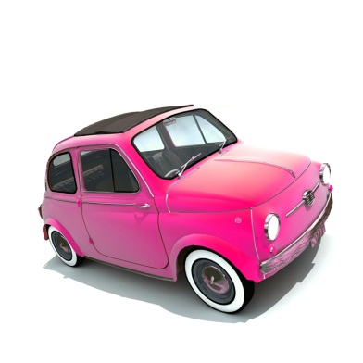

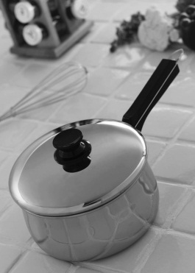Description: C:\Users\user\AppData\Local\Microsoft\Windows\Temporary Internet Files\Content.IE5\AM1I8PN9\MC900088492[1].wmfDescription: C:\Users\user\AppData\Local\Microsoft\Windows\Temporary Internet Files\Content.IE5\S7687CZ2\MC900191789[1].wmf