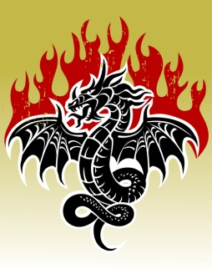C:\Documents and Settings\ljohnson\Local Settings\Temporary Internet Files\Content.IE5\27KI1YQY\MC900195910[1].wmfMyth and Legend Character Study

|  |  |  |  |
| --- | --- | --- | --- |
| Title of Story, Myth or Legend? | 1 | 2 | 3 |
| What is the character’s name? |  |  |  |
| Who or what are they? |  |  |  |
| Do they have any special powers? |  |  |  |
| Are they good or evil? |  |  |  |
| Do they do anything heroic in the story?  (Give details) |  |  |  |
| What happens to them at the end of the story? |  |  |  |
| Words to describe the character |  |  |  |
| What similarites do you notice? | C:\Documents and Settings\ljohnson\Local Settings\Temporary Internet Files\Content.IE5\S6PJCHSA\MC900116082[1].wmf | | |