**Theme: Florence Nightingale, for Grades 2 to 6**

**A. Florence Nightingale**

**Lesson 1**

***Why was Florence Nightingale famous?***

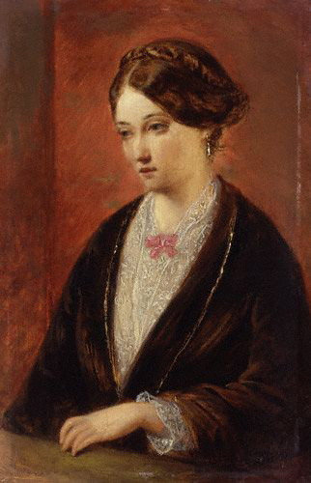

Public domain

Florence became famous for several reasons. She saved the lives of many sick and wounded soldiers in the 1850s during the Crimean War. At that time, Florence also pushed the British government to reform and improve conditions at hospitals. She went on to pioneer the practice of nursing as we know it today. She created an educational system that allowed nurses to receive professional training and qualifications. In 1859, she published a comprehensive guide that continues to be used as an introduction to nursing. Because of these achievements, Florence remains famous today.

Discuss vocabulary to be used and heard during the lesson.

**Vocabulary list suggestions**

|  |  |
| --- | --- |
| famous | patients |
| pioneer | bedridden |
| reform | advise |
| battlefield | mentor |
| Victorian times | objects |
| landowner | similarities |
| society | differences |
| marriage proposal | introduce |
| sanitize | wounded |
| infections | estate |
| nickname | status |
| organize | wealth |
| military | gentleman |
| award | parents |

**Florence word and spelling card**

Teacher prints out a copy for each student of the Florence word and spelling card templates shown below. Students write unfamiliar words they come across during the lessons onto the cards to start building up their own collection of useful words. Students should write the words in pencil so the teacher can ensure correct spelling. Students will find the personal word cards useful for use in future written assignments.

**Florence**

**word and spelling card**

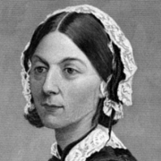

Public domain

|  |
| --- |
|  |
|  |
|  |
|  |
|  |
|  |
|  |
|  |
|  |
|  |
|  |
|  |
|  |
|  |
|  |
|  |
|  |
|  |
|  |
|  |
|  |
|  |
|  |

**Florence**

**word and spelling card**



Public domain

|  |
| --- |
|  |
|  |
|  |
|  |
|  |
|  |
|  |
|  |
|  |
|  |
|  |
|  |
|  |
|  |
|  |
|  |
|  |
|  |
|  |
|  |
|  |
|  |
|  |

**Lesson 2**

***Background information on Florence Nightingale***

The lesson will inform children about the life of Florence Nightingale and acquaint them with conditions in Victorian times

Florence Nightingale was born on May 12, 1820, in Florence, Italy. She was named “Florence” after the city where she was born. She had an older sister called Parthenope. Her parents were very wealthy. Her father William was a landowner. She grew up at two estates--Lea Hurst, in Derbyshire, and Embley Park, in Hampshire. Her father taught her German, French, and Italian. From a very young age, Florence helped sick and poor people from the village close to their estate.

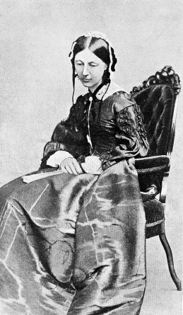

Wellcome Library, London, Keene of Derby, CC BY 4.0

By the age of 16, she felt that her calling and purpose was to become a nurse. Her mother did not like this idea at all because nurses were looked down upon in society. Her mother was very aware of the family’s status and wealth. She wanted Florence to live up to the family’s social standards by accepting a marriage proposal from Richard Monckton Milnes, a gentleman from a similar wealthy background. Florence, then 17 years old, refused his proposal, and her mother was very unhappy about that.

Florence received nursing training at Kaiserwerth, a hospital in Germany. Florence was sad and unhappy when she heard that, during the Crimean War, more soldiers were dying from poor hospital sanitation conditions than from battlefield injuries. Florence organized a group of nurses and traveled with them to a military hospital called Scutari, near Istanbul, in Turkey. At Scutari, she introduced cleaning and sanitation methods that helped wounded soldiers fight off infections. She ensured that the wounded soldiers were taken care of around the clock and that they had warm blankets, clean bedding, clean water, and healthy food to eat. She herself visited patients at night carrying a lamp so she could see well. This led to her being nicknamed the "Lady with the Lamp."

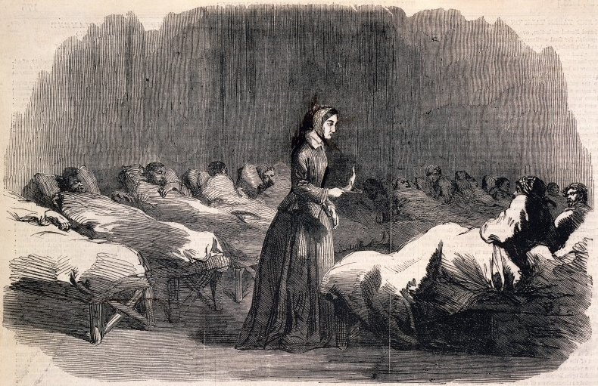

Wellcome Library, London, CC BY 4.0

In 1883, Florence met Queen Victoria and Prince Albert, with whom she discussed improvements needed at military hospitals. Queen Victoria awarded Florence the Royal Red Cross to thank her for all of her hard work as a military nurse. But Florence’s hard work during the Crimean War affected her health, and she became ill and bedridden. Even so, she continued to write, advise, and mentor until her death on August 13, 1919.

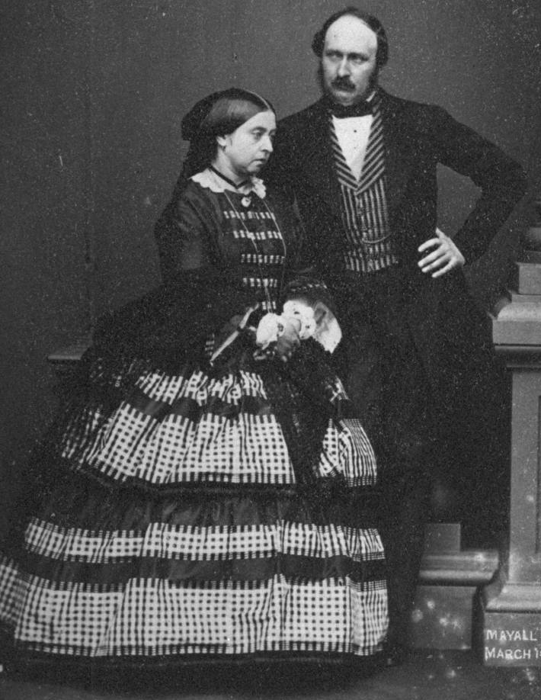

Victoria and Albert

John Jabez Edwin Mayall, Public Domain

**Literacy:** Children to put the words from vocabulary list covered during the lessons into short, informative sentences. Another option is to read a story or extract from a book on Florence Nightingale.

**Math:** Children do calculations based on numbers from the lessons, using dates and currencies.

**Geography:** Children learn about the basics of Italy, England, Germany, and other countries. Other documents on Italy, England, and Germany form part of this lesson plan.

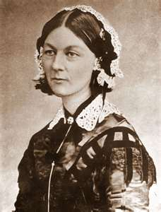

Florence Nightingale

Public domain

**Art:** Children make their own portraits of Florence or discuss art and artists from Italy. View, discuss, and compare architecture of buildings in each country.

**Science:** Discuss the following aspects of each country covered in Geography: foods, plants, animals, buildings, languages spoken, means of transport, etc. How are they different, how are they the same? How would you travel from those countries to where you live?

**Music:** Make use of opera and classical music, especially that of Andrea Bocelli. He is a role model because he studied to become a lawyer, became a singer, and achieved a lot even though he is blind. Children can learn in Circle Time how to relate to and respect people who are blind or differently abled.

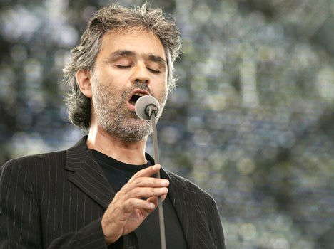

Andrea Bocelli

Photo by laurentius87, CC BY-SA 2.0, https://creativecommons.org/licenses/by-sa/2.0/legalcode

**Assessment:** Answer questions on worksheet or do a quiz game as revision.

**Lesson 3**

***What is being a nurse like?***

C:\Users\ES\AppData\Local\Microsoft\Windows\Temporary Internet Files\Content.IE5\SHMQQQ1P\MC900446070[1].wmfChildren to learn about the past by comparing features of past life with modern equivalents. By looking at a modern nurse, children will fully understand the role of Florence Nightingale, as well as being able to see how working as a nurse has changed over time. Make use of pictures of Florence Nightingale during her time as a nurse. Compare these with pictures of nurses of today. Work out a set of questions to be discussed around the pictures.

Public domain

C:\Users\ES\AppData\Local\Microsoft\Windows\Temporary Internet Files\Content.IE5\TKIHPLO3\MC900347925[1].wmf**Topic of discussion:** Objects used by Florence

during her times and how

they differ from supplies used today

Public domain

C:\Users\ES\AppData\Local\Microsoft\Windows\Temporary Internet Files\Content.IE5\BNEN2CAC\MC900357981[1].wmf**Literacy:** Shared writing – children to list similarities and differences under the headings of Same and Different*.* Make a list of nursing supplies used during the time of Florence Nightingale. Teach students how to make lists and correct use of commas between list items.

**Assessment:** Check shared writing for correct information.

Public domain

**Lesson 4**

***Where is the Crimea?***

C:\Users\ES\AppData\Local\Microsoft\Windows\Temporary Internet Files\Content.IE5\ONI2BGXV\MC900295588[1].wmfStudents make use of a world map to indicate where they live in relation to the Crimea. Talk about the different means of travel available in Victorian times. Make use of a map showing the route Florence Nightingale used to travel from England to the Crimea.

**Group discussion:** On the forms and means of travel

we could use today to visit the Crimea. Provide background on the Crimean War.

**Literacy:** Write unfamiliar words on Florence new-word cards**.**

Public domain

**Design and technology:** Students could make ships out of papier-mâché.

**Drama and role play:** Children learn more about nursing

and the role of Florence Nightingale during the Crimean War

through drama and role play.

**C:\Users\ES\AppData\Local\Microsoft\Windows\Temporary Internet Files\Content.IE5\BNEN2CAC\MC900028168[1].wmf**

**Geography:** How to read the key on a map

and how to read a compass.

Draw a compass to indicate the different directions.

Public domain

**Assessment:** Children to color a map indicating places Florence Nightingale visited.

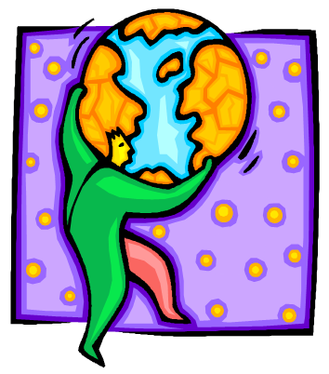

Public domain

**Lesson 5**

***Listening to Florence speaking***

We can hear a rare 1890 recording of Florence Nightingale’s voice at <https://www.youtube.com/watch?v=ax3B4gRQNU4>. Show enlarged copies of the words she is saying. Ask the children to listen to the sound of the recording. How do we know it was made many years ago? Discuss how this way of talking seems old fashioned to us now. Pick out words and phrases that we would not use when we are talking today.

**Music and art:** Re-enact key scenes from the life of Florence Nightingale through drama and song.

Students could compose their own song using historical background on Florence Nightingale. Herewith a song that was composed by my Primary 2 class in Hong Kong. The song was sung to their favorite tune from “High School Musical”.

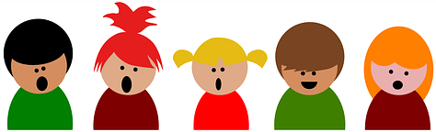

CC0 Public Domain

**Florence Song**

|  |  |
| --- | --- |
| **Verse 1**  Florence was born in 1820.  She was born in Florence, Italy  Her parents were rich.  They wanted her to marry  a rich man and live  happily, forever [x2]  “Oh no!” she said.  “I want to be a nurse,  To help the soldiers.”  Florence died in 1910  And was 90 years old. | **Verse 2**  Victoria was Queen.  Her husband was Albert.  They had 9 children.  Oh, when Albert died  She only wore black.  Florence was known  As the lady with the lamp,  The lady with the lamp.  Einstein was born when  Florence was 59,  When Florence was 59.  Sacajawea was 64  When Florence was born. |

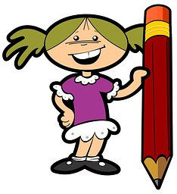

**Literacy:** Imagine you are a journalist and you are going to write story to tell others about Florence Nightingale. Makes notes as you interview Florence and then write up your own story giving an account of her life as a nurse.

CC0 Public Domain

**Assessment:** Students complete the following worksheet. What do we know about Florence Nightingale?

|  |  |  |  |  |  |
| --- | --- | --- | --- | --- | --- |
| |  | | --- | | **Where did she live at different times of her life?** | | **What was she like?** | | **What did she do?** | | **Where did she work?** | | **Who worked with her?** | |



CC0 Public Domain

**Lesson 6**

***Hospitals of the past and present***

Students research and compare what the hospital at Scutari was like during the Crimean War versus what a hospital is like today. Students imagine they are a nurse or a doctor at a hospital in Scutari and in a modern-day hospital and write up an account of the differences.

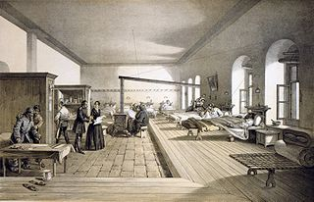

Hospital in Scutari, Turkey, now part of Istanbul.

Public domain

**Geography:** Students do research about the people, culture, customs, food, art, architecture, currency, and languages of Turkey.

**Diary time**: Write about a day in the life of Florence Nightingale as a nurse.

**Lesson 7**

***Sequencing events in Florence Nightingale’s life***

Read and share with the class the simple version of the story of Florence Nightingale’s life from “Florence Nightingale” (Usborne Famous Lives). Make use of pictures to illustrate various scenes from her life and have separate sentence cards of key events from her life.

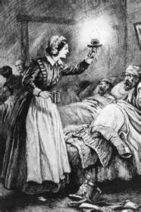

Public domain

**Literacy:** Arrange the children in small groups. Give each group a set of cards with the sentences arranged in the wrong order. Children to sequence the main events from the story. When the groups are satisfied with their sequences help them to check their sentences.

**Art:** Draw a story sequence or set of pictures to illustrate the story of Florence Nightingale.

**Lesson 8**

***Role playing on Florence Nightingale***

Classmates to share their knowledge of Florence Nightingale through drama and role play with the rest of the school at assembly using work produced over the past seven lessons.



CC0 Public Domain



CC0 Public Domain

**Preparation:** Select props for the assembly. Group the children to work on their presentations of different aspects of the theme:

* A brief biography of Florence’s life
* Pictures and paintings of Florence’s life
* Pictures of the hospital where she and her nurses worked
* Stories from the nurses who worked with her
* Two children to introduce the sound recording of Florence
* People alive at the same time as Florence Nightingale

Children can show drawings to illustrate their presentations, and each child in the class should be given an opportunity to participate in their group’s presentation.

**B. People who lived at the same time as Florence Nightingale**

**Lesson 9**

***Mary Seacole, Jamaican nurse***

Mary’s mother was a nurse in Jamaica who treated people with local medicines and herbs, and her father was a Scottish soldier. As a child, Mary played at being a nurse to her dolls and pets. At the age of 12, she started to help her mother nurse the sick.

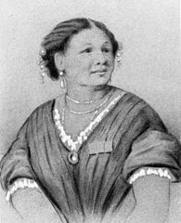

Mary Seacole

Public domain

Mary was a nurse during the same period as Florence Nightingale. She traveled to the Crimea, where she visited Florence Nightingale. Mary made different plans than Florence. Florence mostly treated soldiers at the hospital, while Mary decided to go to the front line to help wounded soldiers. Discuss the meaning of “front line”. Mary started a general store, and it expanded into a “British hotel” at which wounded officers could stay.

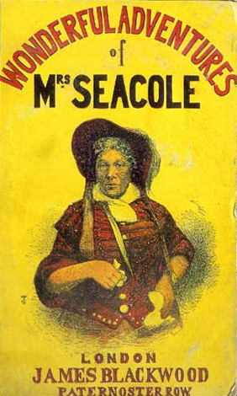

Public domain

Explain that we learn a lot about Mary and her life through information in her autobiography, “Wonderful Adventures of Mrs. Seacole in Many Lands”. It is a non-fiction book. Teacher can read a passage to the children. Students explain their understanding of the meaning of “autobiography” and “non-fiction book”.

Mary’s book can be found at: <http://digital.library.upenn.edu/women/seacole/adventures/adventures.html>

**Geography:** Find Jamaica on a world map. How would you travel to Jamaica from where you live? Discuss the different forms of transport.

**Literacy:** Write new words on a Mary new-word card. Write sentences giving descriptions and examples of fiction and non-fiction books. What does an illustrator do?

**Assessment:** Divide class into groups and do a quiz game.

**Music:** Teacher to source music from Jamaica and another country. Allow students to listen to the music and discuss the tempos, rhythms, and instruments used. How is the music of Jamaica different from the music of the other country?



CC0 Public Domain

**Art:** Students make their own Jamaican musical instruments, such as maracas and drums.

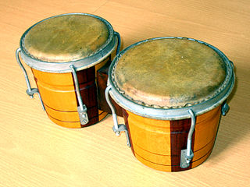

CC0 Public Domain (left) and photo by cralize, CC-BY-SA-3.0

**Lesson 10**

***Queen Victoria: Queen of England 1837-1901 and Empress of India 1876-1901***

Victoria was born at Kensington Palace in London on the 24th of May 1819. In 1837 at the age of 18, she became queen of the United Kingdom of Great Britain and Ireland. She later married Albert, a prince from Germany. They had nine children.

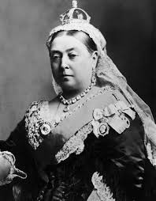

Public domain

Albert died of typhoid when he was 42. Queen Victoria mourned the death of Albert all her life and wore black clothes until the end of her reign.

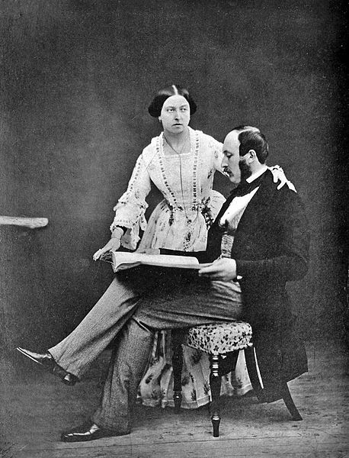

Queen Victoria & Prince Albert

Public domain

Victoria was the first monarch to live in Buckingham Palace. She was queen for 63 years and 7 months.

**Lesson 11**

***Clara Barton: American nurse and founder of the American Red Cross***

Clara was born on Christmas day, December 25, 1821, in North Oxford, Massachusetts. She grew up on a farm together with her two sisters and two brothers. Her mother taught the children that all people should be treated equally. Clara’s brothers and sisters taught her how to read and write, and she did very well at school.

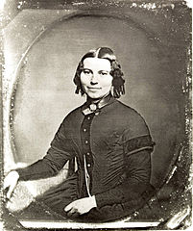Public domain

Clara was a hard worker and often took care of sick animals on the farm. She also took care of her brother David, who became very sick after he fell off the roof of a barn. Clara spent nearly two years looking after him, and it was during this time that she realized that she enjoyed taking care of others. He eventually got better.

When Clara was 17 she started teaching at a summer school. She qualified as a teacher in 1851 after she completed her studies at a college in New York. She taught at a private school but worked very hard to open a free public school, which eventually had 600 students.

The Civil War broke out, and many soldiers arrived in Washington DC. Clara noticed that they had few supplies to take care of their wounds. Soon she organized a way to obtain supplies and to have them sent to the front lines. Clara was very brave and went to battlefields to nurse soldiers back to health. She became known as the “Angel of the Battlefield”.

On a trip to France, Clara worked for the International Red Cross, which helped soldiers. This gave her the idea to start the American Red Cross, which she founded on May 21, 1881. The American Red Cross today helps people recover after disasters like earthquakes and floods, and it also has a blood donation program that saves the lives of many people.

Clara never married and never had children as she considered the soldiers to be like family members. She died on April 12, 1912, in Glen Echo, Maryland, US, at the age of 90.

**Lesson 12**

***Alexander Graham Bell invented the telephone***



CC0 Public Domain

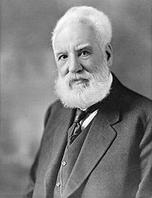

Public Domain

Library and Archives Canada

Alexander was a scientist, engineer, and inventor. He was born in Edinburgh, Scotland, on March 3, 1847. He died on August 2, 1922, at the age of 75. Both his mother and his wife were deaf. That inspired and influenced a lot of his work. Bell later moved with his family to Canada and the United States.

He began working with deaf people, and in 1872 founded a school for the deaf. Alexander and Helen Keller met each other at this school.

One of Alexander Graham Bell’s best known inventions was the telephone.

He also helped create the National Geographic Society.

**Lesson 13**

***Louis Braille developed a system that enabled blind people to read***

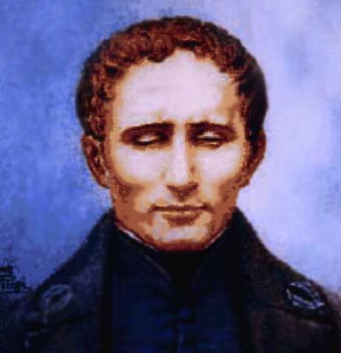

Public domain

Louis was born in 1809, in Paris, France. As a shoemaker, his father used various tools. Among the tools was a sharp-pointed awl. Louis picked the awl up, and it slipped, pierced one of his eyes, and damaged it. It caused an infection that left Louis completely blind.

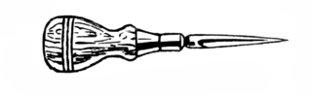

An awl

[Pearson Scott Foresman](https://commons.wikimedia.org/wiki/Commons:Pearson_Scott_Foresman), public domain

He was 10 years old when he went to a special school for blind children in Paris. At the school students were taught to read and write using a system of raised letters. Louis found the system very hard to use, as it was difficult to tell the letters apart. Charles Barbier, a captain in the French army, paid a visit to the school, as he had developed a system that allowed soldiers to read messages in the dark. The system consisted of a series of raised dots. Louis adapted that system so it could be used by blind people.

Louis became a teacher, but it was only after his death that the Braille system that is used in almost every country in the world today was adopted and used.

Below is an example of Braille. See if you can write your name in Braille.

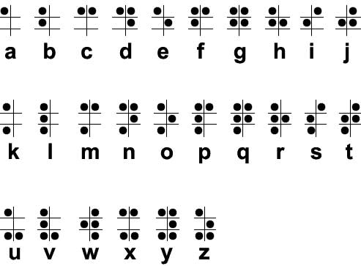

Public domain

**Lesson 14**

***Mark Twain, author of “Tom Sawyer” and “Huckleberry Finn”***

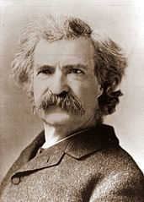

Public domain

Mark is one of the best known American authors. He was born in St. Petersburg, Missouri. The adventures of both Tom Sawyer and his friend Huckleberry Finn are still very popular today. Mark Twain died in 1910.

**Literacy:** Read from the adventures of Tom Sawyer and Huckleberry Finn to the class, or find a film based on the stories that the class can watch.

**Lesson 15**

***Helen Keller paved the way for deafblind people***

Helen was born on June 27, 1880. When she was 18 months old she developed a high fever that caused her to become blind and deaf. Not being able to see or hear was very difficult for Helen, as she did not know how to communicate with her parents or other people. She became unruly and often had temper tantrums out of frustration.

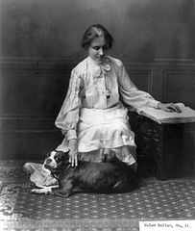

Public domain

Her parents were referred to Alexander Graham Bell. Even though he was well known for his inventions, he also chose to work as a teacher of deaf children in Washington DC. Both his mother and wife were deaf.

Alexander Graham Bell referred Helen’s parents to the Perkins Institution in Boston, which sent Anne Sullivan to teach Helen how to communicate. Anne taught Helen how to read Braille, the system developed by Louis Braille. Helen became the first deaf and blind person to graduate from college. She became well known and met famous people like Thomas Edison and Mark Twain. Helen died on June 1, 1968, at the age of 88.

**Lesson 16**

***Thomas Edison invented the electric light bulb***

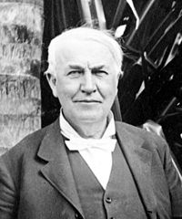

Public domain

Thomas was born on February 11, 1847, in Milan, Ohio, and died on October 18, 1931, in New Jersey.

He was not a very good scholar. His mother, a teacher, decided to home-school him. He invented over 1,000 items, including the phonograph and the motion picture camera. The best known item he invented is the electric light bulb.



Elembis, public domain

**Art:** Make and decorate a shoebox home.

**Science:** Use wiring to connect batteries and small bulbs. Install the bulbs to provide lighting in the shoebox home.

**Lesson 17**

***Jean François Champollion was the first Westerner to decipher Egyptian hieroglyphics***

Jean, a brilliant historian and linguist, was born in Figeac, France, on December 23, 1790. By the age of 16 he could speak six Middle Eastern languages. He deciphered the picture writing of the ancient Egyptians, “hieroglyphics”. He worked very hard, travelled a lot, and worked very long hours. This made him ill, and he died in Paris in 1832 at the age of 41.

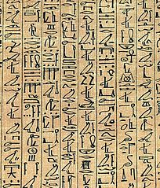

Hieroglyphics

Public domain

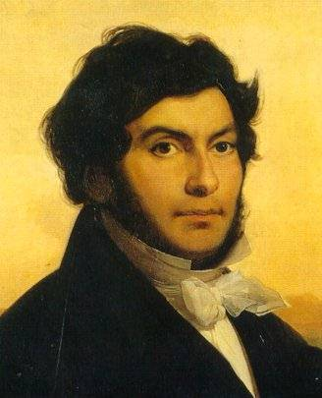

Léon Cogniet, Public Domain

**Lesson 18**

***Scientist Albert Einstein discovered the theory of relativity***

Albert Einstein was one of the world’s most important scientists. Albert was born in Ulm, Germany, on March 14, 1879. He was from a Jewish family. Many people see him as the smartest scientist the world has ever known. He is best known for the theory of relativity and the formula E=mc2 (energy equals mass multiplied by the square of the speed of light). Einstein loved math and science. He spent most of his childhood in Germany but later went to school in Switzerland. In 1933 he moved to the United States. Einstein became a US citizen in 1940. He died in Princeton, New Jersey, on 18 April 1955 at the age of 76.



CC0 Public Domain

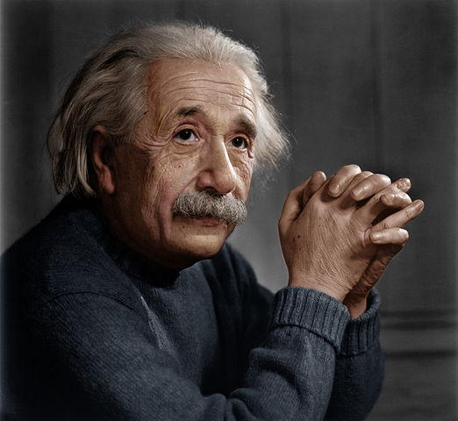

CC BY-SA 4.0

Copyright 2015 by Maria Elizabeth Lotter