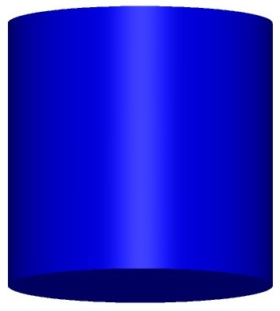

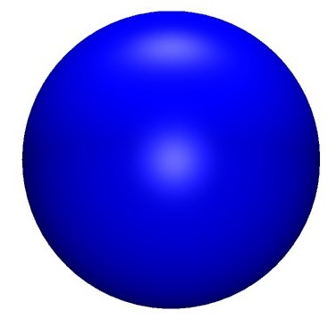

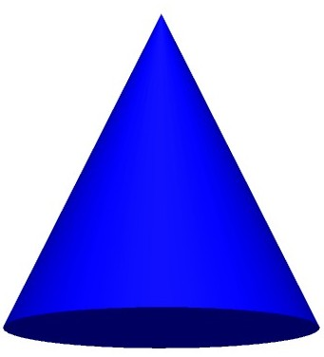

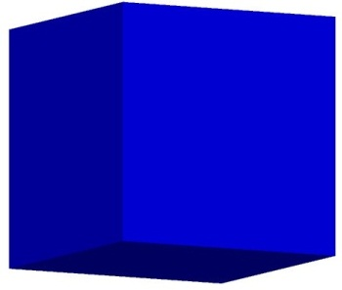

|  |  |  |
| --- | --- | --- |
| http://www.teacherfiles.com/clipart/shapes/clipart_cone.jpg | http://www.teacherfiles.com/clipart/shapes/clipart_cube.jpg | http://www.teacherfiles.com/clipart/shapes/clipart_cone.jpg |
| http://www.teacherfiles.com/clipart/shapes/clipart_sphere.jpg | http://www.teacherfiles.com/clipart/shapes/clipart_sphere.jpg | http://www.teacherfiles.com/clipart/shapes/clipart_cylinder.jpg |

|  |  |  |
| --- | --- | --- |
| http://www.teacherfiles.com/clipart/shapes/clipart_cone.jpg | http://www.teacherfiles.com/clipart/shapes/clipart_cube.jpg | http://www.teacherfiles.com/clipart/shapes/clipart_cone.jpg |
| http://www.teacherfiles.com/clipart/shapes/clipart_cylinder.jpg | http://www.teacherfiles.com/clipart/shapes/clipart_sphere.jpg | http://www.teacherfiles.com/clipart/shapes/clipart_cylinder.jpg |

|  |  |  |
| --- | --- | --- |
| http://www.teacherfiles.com/clipart/shapes/clipart_cone.jpg | http://www.teacherfiles.com/clipart/shapes/clipart_cube.jpg | http://www.teacherfiles.com/clipart/shapes/clipart_cone.jpg |
| http://www.teacherfiles.com/clipart/shapes/clipart_sphere.jpg | http://www.teacherfiles.com/clipart/shapes/clipart_sphere.jpg | http://www.teacherfiles.com/clipart/shapes/clipart_cylinder.jpg |

|  |  |  |
| --- | --- | --- |
| http://www.teacherfiles.com/clipart/shapes/clipart_cone.jpg | http://www.teacherfiles.com/clipart/shapes/clipart_cube.jpg | http://www.teacherfiles.com/clipart/shapes/clipart_cone.jpg |
| http://www.teacherfiles.com/clipart/shapes/clipart_sphere.jpg | http://www.teacherfiles.com/clipart/shapes/clipart_sphere.jpg | http://www.teacherfiles.com/clipart/shapes/clipart_cylinder.jpg |

|  |  |  |
| --- | --- | --- |
| http://www.teacherfiles.com/clipart/shapes/clipart_cone.jpg | http://www.teacherfiles.com/clipart/shapes/clipart_cube.jpg | http://www.teacherfiles.com/clipart/shapes/clipart_cylinder.jpg |
| http://www.teacherfiles.com/clipart/shapes/clipart_sphere.jpg | http://www.teacherfiles.com/clipart/shapes/clipart_sphere.jpg | http://www.teacherfiles.com/clipart/shapes/clipart_cube.jpg |

|  |  |  |
| --- | --- | --- |
| http://www.teacherfiles.com/clipart/shapes/clipart_cone.jpg | http://www.teacherfiles.com/clipart/shapes/clipart_sphere.jpg | http://www.teacherfiles.com/clipart/shapes/clipart_sphere.jpg |
| http://www.teacherfiles.com/clipart/shapes/clipart_cube.jpg | http://www.teacherfiles.com/clipart/shapes/clipart_cylinder.jpg | http://www.teacherfiles.com/clipart/shapes/clipart_cylinder.jpg |

|  |  |  |
| --- | --- | --- |
| http://www.teacherfiles.com/clipart/shapes/clipart_cone.jpg | http://www.teacherfiles.com/clipart/shapes/clipart_cube.jpg | http://www.teacherfiles.com/clipart/shapes/clipart_cone.jpg |
| http://www.teacherfiles.com/clipart/shapes/clipart_sphere.jpg | http://www.teacherfiles.com/clipart/shapes/clipart_cube.jpg | http://www.teacherfiles.com/clipart/shapes/clipart_cylinder.jpg |

|  |  |  |
| --- | --- | --- |
| http://www.teacherfiles.com/clipart/shapes/clipart_cone.jpg | http://www.teacherfiles.com/clipart/shapes/clipart_cube.jpg | http://www.teacherfiles.com/clipart/shapes/clipart_cone.jpg |
| http://www.teacherfiles.com/clipart/shapes/clipart_sphere.jpg | http://www.teacherfiles.com/clipart/shapes/clipart_sphere.jpg | http://www.teacherfiles.com/clipart/shapes/clipart_cylinder.jpg |