9
10
8
7
6
5
4 |  |  |  |  |  | x K
3
2
1
1  0  0 | 2 | 3 | 4 | 5 | 6 | 7 | 8 | 9 | 10 | 11 | 12

Plot the following points on the grid and label them with the letter. Join the letters alphabetically with straight lines.
One is done for you.
A = (4,2) F = (9,8) K = (6.5,4)
B = (3,4) G = (7,8) L = (6,2)
C = (4,6) H = (6,6) M = (5,0)
D = (5,8) I = (7,5) N = (5,2)
E = (7,9) J = (6,5) O = (4,0)
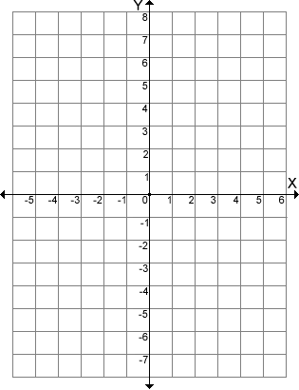
Plot the following points on the grid and label them with the letter. Join the letters alphabetically with straight lines.
A = (-4,-5) F = (4,5) K = (2,-2)
B = (-5,-2) G = (2,5) L = (0,-5)
C = (-3,3) H = (0,3) M = (-1,-8)
D = (-2,5) I = (2,1) N = (-2,-5)
E = (2,7) J = (0,1) O = (-3,-8)

9
10
8
7
6
5
4
3
2
1
1  0  0 | 2 | 3 | 4 | 5 | 6 | 7 | 8 | 9 | 10 | 11 | 12

Draw your own picture then write the coordinates of each point below. Don’t forget to label your points with the correct letter on the grid.

