I need a holiday….Camping or Glamping?

In your groups use the following pages to plan a holiday for 2 adults and 2 children.
Your holiday will last for 3 nights – plan wisely
Petrol costs 15p per mile
You must:
- Choose 1 location from the list
- Choose at least 2 activities from the list
- Choose at least 1 food pack from the list
- Choose as many items from the equipment list
MOST IMPORTANTLY – WORK AS A TEAM!
YOU HAVE A BUDGET OF £800
Don’t exceed (go over) your budget !
Use a calculator if you need to and use paper for working out your choices before putting your final costs on the budget planner at the end.

LOCATIONS
You need to choose one location from this list.
Name | Details | Price
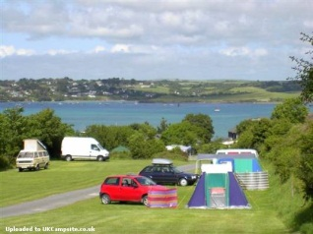  Dingle Dell Campsite | - Electric hook up is 15% of cost per night  - Free car park  - Children’s playground, football pitch and games arcade on site | Adults - £10 per night  Children - free
 |  | Distance Away
 |  | 26 miles further than Watsons Waste
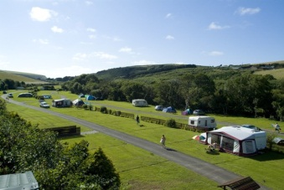  Watsons Waste  Campsite | - Electric hook up is 15% of cost per night  - Car park £1 daily  - Children’s playground, football pitch and swimming pool on site | Price
 |  | £36 per tent per night
 |  | Distance Away
 |  | 120 miles from home
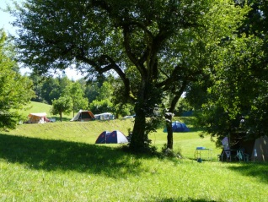  Long Meadow  Campsite | - Electric hook up is 15% of cost per night  - Car park £1 daily  - 10% off leisure activities per family  - Children’s playground, football pitch, swimming pool and games arcade on site | Price
Adults - £15 per night
Children - £10 per night

 |  | Distance Away
 |  | 10 miles nearer than Dingle Dell
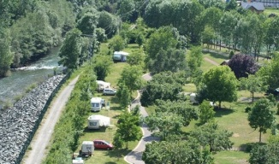  Rocky River Retreat | - Electric hook up is 10% of cost per night  - Car park free  - Children’s playground, football pitch and games arcade on site | Price
 |  | £30 per tent per night
 |  | Distance Away
 |  | Twice the journey length as Watsons Waste
ACTIVITIES
You need to choose at least two activities from this list.
Activity | Details | Price
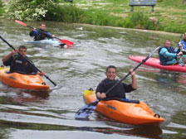  Canoeing | - Enjoy a fun half day of canoeing on the lakes  - Enjoy a BBQ lunch for an additional £5 per person  - Wetsuit hire £3 per person | Adults - £15  Children - £10
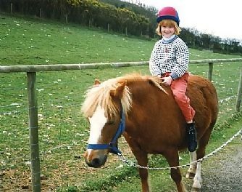  Pony Trekking | - Enjoy a fun filled day pony trekking through the hills  - Enjoy a picnic in the hills for an additional £6 per person  - Equipment hire an additional £1 per person | Price
Adults - £16
Children - £10

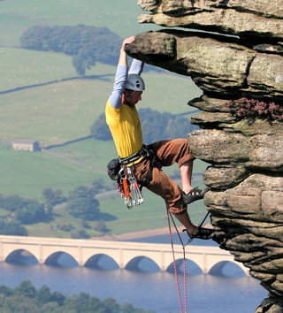  Climbing | - Enjoy a fun filled day learning to climb, starting off on the training wall before moving to the great outdoors.  - Lunch is an additional £4 per person  - Equipment hire is an additional £5 per person with 50% back on return of items | Price
Adults - £23
Children - £13

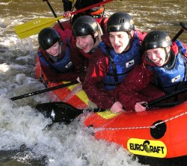  White Water Rafting | - Enjoy a fun filled morning white water rafting through the valleys before a BBQ lunch in the forest.  - Lunch included | Price
Adults - £15
Children - £10

FOOD PACKS
You can choose as much as you want from this list. Remember to keep within your budget!
Food Pack | Details | Price
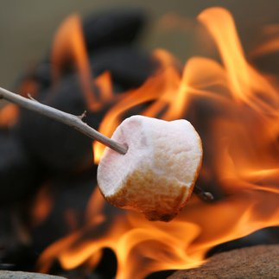  Food pack A | Includes:  5xCans of beans  1x Pack of rice  5x Pack of noodles  2x Box of cup-a-soup (6 packets per box)  1x Large box of cornflakes  2x Tins of chopped tomatoes  1x 24 pack crisps  1x Pack sausages  2x Pack of bacon  1 dozen eggs  2x Pack of boiled sweets  20x flapjack/oatmeal bars | £55
Food pack B | Includes:  1x Ketchup  2x Large cartons UHT milk  10x Litre bottle of water  1x Box of tea bags  1x Pack of sugar  2x Pack of boiled sweets  1x Jar of coffee  1x Tub of salt  1x Tub of pepper  1x Loaf of bread  1x Bottle cooking oil  1x Jar of jam | £25
Food pack C | Includes:  1x Pack of 12 burger buns  1x Pack of 12 burgers  1x Pack of 12 chicken drumsticks  1x Tub of margarine  2x Bags of chopped lettuce  1x Box of tomatoes  1x Cucumber  1x Bag of apples  24x Chocolate bars  6x Tin of beans  5x Pack of noodles  2x Box of cup-a-soup (6 packets per box)  4x Pack of marshmallows | £75
EQUIPMENT
You can choose as much as you want from this list.
Remember to keep within your budget!
Item | Details | Price | Tick
6 man tent | Comes with free electricity lead | £109.00
4 man tent | With added porch | £89.00
Electricity Lead | 12 meters | £15.00
Cool Box | Keeps food chilled for 24 hours | £18.00
Camping Fridge | Electricity required | £35.00
Torch | Batteries included | £3.00
Lantern | Wind-up no batteries required | £4.00
Butane gas bottle | With free basic cooking stand attachment | £41.00
Camping stove | 2 cooking rings and grill, butane gas required | £76.00
Frying Pan |  | £5.00
Small Pan |  | £4.00
Pots and Pan set | Includes frying pan, 1 small and 2 large pans | £10.50
Basic picnic set | Includes 4 plastic cups, 4 plates, 4 bowls and 12 piece cutlery set | £10.00
Deluxe picnic set | Includes 4 tin cups, 4 plates, 4 bowls, 12 piece cutlery set & can opener | £14.00
Can opener |  | £2.50
Camp Bed | Fold up single camp bed | £15.00
Air Bed | Double air bed, requires inflating | £35.00
Sleeping Bag | Single sleeping bag to fit all sizes | £12.00
Army Knife set | Includes can opener, bottle opener and knives | £18.00
Stove Lighter | Ignites at a touch of a button | £5.00
Box of Matches |  | £1.50
Washing up set | Includes bowl, dish cloth and washing up liquid | £5.00
Duvet & Pillow Set | Single Duvet & Pillow set for those home comforts | £16.00
Tent Carpet | Give your tent a splash of luxury and warmth | £50.00
Tent Heater | Requires electricity | £25.00
Portable Television | Requires electricity | £75.00
Wind-up radio | No batteries required | £16.00
CD Player | Electricity required | £35.00
DVD Player | Includes 10 DVDs requires Television and Electricity | £45.00
Camp chairs | 4 x fold up camping chairs | £40.00
Sofa | Requires inflating, seats 2 | £30.00
Table and chairs | Folds away for easy storage, seats 4 | £25.00
Wardrobe | Fold away storage cupboard | £15.00
Hair dryer | Requires electricity | £20.00
Hair Straighteners | Requires electricity | £30.00
Kettle | Requires electricity | £8.00
Toaster | Requires electricity | £8.00
Tent peg pack | Additional tent pegs | £5.00
Rubber Mallet | For hammering those pesky tent pegs in | £2.00
Tea Towels |  | £2.50
Tent repair pack | An essential for any camping holiday | £4.00
Games Console | Requires TV and electricity – comes with 1 game | £125.00

BUDGET PLANNER
 | Cost | Total Cost
Campsite

Electric Hook up
Petrol Money

Activities

Equipment

Final Cost ___________

