Division with remainders
Share the objects equally in the shopping bags, watch out for remainders!
16 carrots shared into 2 bags = 17 ÷ 2 = 8 r 1
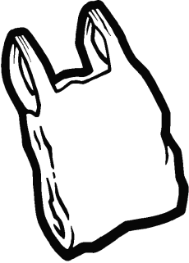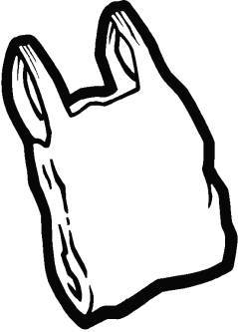
13 chocolates grouped into 2 bags = _________________

27 sweets divided into 2 bags = _________________

33 dolls shared into 2 bags = ___________________

29 cars shared into 2 bags = __________________

Division with remainders
Share the objects equally in the shopping bags, watch out for remainders!
17 carrots shared into 4 bags = 17 ÷ 4 = 4 r 1
13 chocolates grouped into 4 bags = _________________

42 sweets divided into 4 bags = _________________

33 dolls shared into 4 bags = ___________________

23 cars shared into 4 bags = __________________

Division with remainders
Share the objects equally in the shopping bags, watch out for remainders!
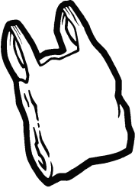
19 carrots shared into 8 bags = 19 ÷ 8 = 2 r 3

25 chocolates grouped into 8 bags = ___________________
44 sweets divided into 4 bags = _____________________
22 dolls shared into 8 bags = __________________
33 cars shared into 8 bags = ___________________
47 cans grouped into 8 bags = ____________________
Division with remainders
Share the objects equally in the shopping bags, watch out for remainders!
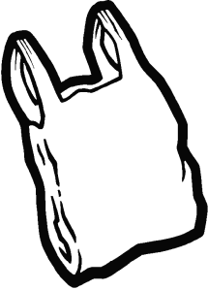
20 carrots shared into 3 bags = 20 ÷ 3 = 6 r 2

25 chocolates grouped into 3 bags = ___________________

34 sweets divided into 3 bags = _____________________

11 dolls shared into 3 bags = __________________

43 cars shared into 3 bags = ___________________

Division with remainders
Share the objects equally in the shopping bags, watch out for remainders!
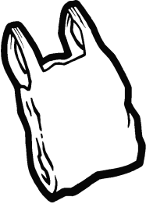
21 carrots shared into 6 bags = 20 ÷ 6 = 3 r 3
25 chocolates grouped into 6 bags = ___________________
34 sweets divided into 6 bags = _____________________
10 dolls shared into 6 bags = __________________
45 cars shared into 6 bags = ___________________
67 cans grouped into 6 bags = _____________________

