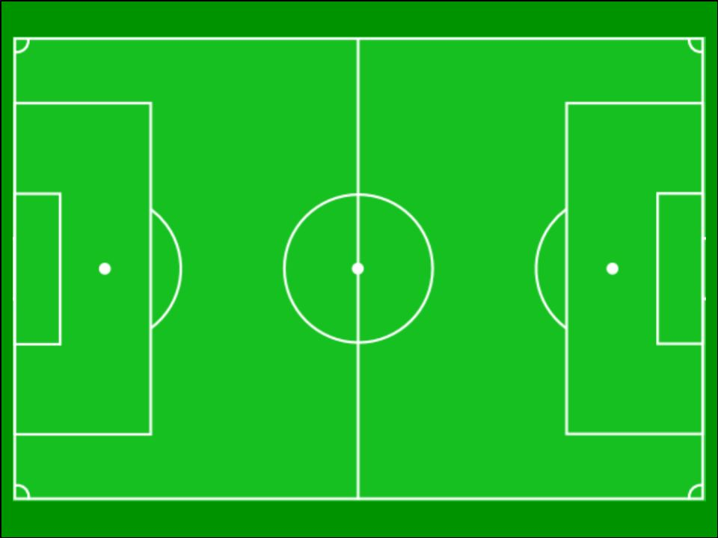
Football Coordinates
11
10
9
8
7
6
5
4
3
2
0
1
7
6
5
4
3
2
0
1
A first-quadrant coordinates grid, overlaid onto a football pitch image.

I normally enlarge this to A3. Suitable for any coordinates activity in the first quadrant. I like to combine it with images of football players, so children can place players and organise a team on the pitch. Children could draw their own players.

