GONE TO THE DOGS!

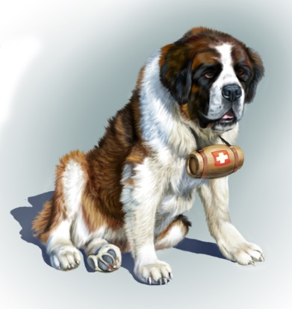
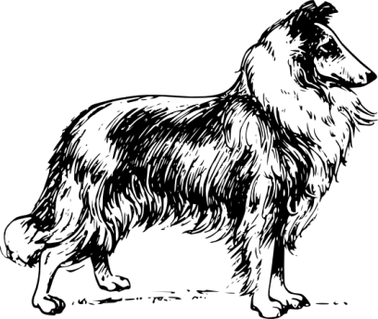
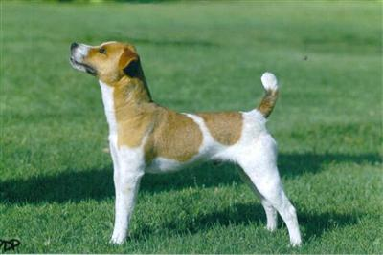
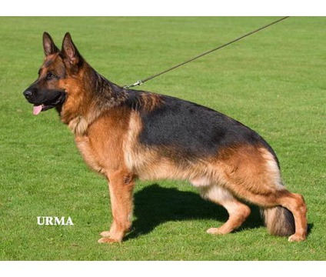
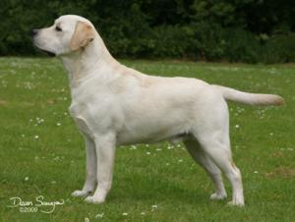
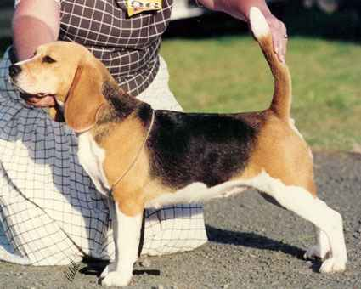
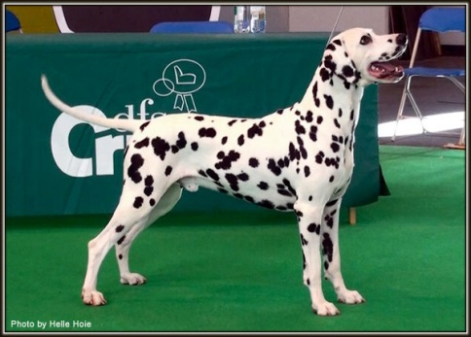
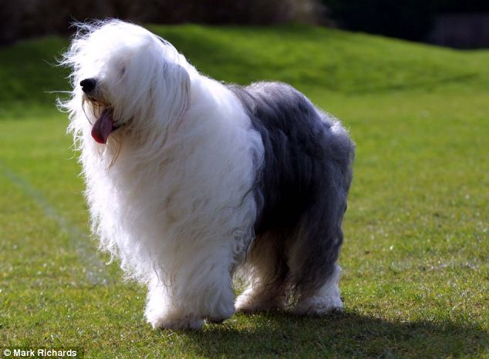
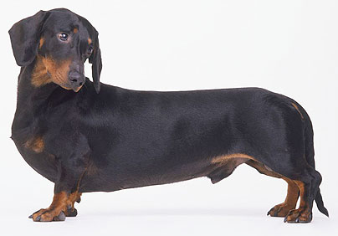
The amount of food you give your dog depends on the breed (kind) of dog and how old it is. Here are the breeds and average weights of adult dogs of different breeds. Look at the information and answer the questions.
St Bernard 80kg
Collie 34kg
Jack Russell Terrier 8kg
German Shepherd 46kg
Labrador 32kg
Beagle 16kg
Dalmation 22kg
Retriever 39kg
Old English Sheepdog 29kg
Daschund 7kg

- Which dog weighs the most? _________________________
- Which dog is the lightest in weight? ________________________
- How many dogs weigh more than 40kg? _________________________
- How much heavier is the Dalmatian compared to the Jack Russell Terrier? ____________________
- How much more does the German Shepherd weigh than the Beagle? ___________________
- How many dogs weigh less than 30kg? ___________________________
- How much more does the Saint Bernard weigh than the Old English Sheepdog? _________________
- What is the total weight of the Old English Sheepdog and the Irish Terrier? ___________________
- What is the difference in weight between the heaviest dog and the lightest dog? ______________
- Which dogs weigh between 4kg and 11kg? __________________________________
GONE TO THE DOGS continued!

- You work at the vet’s surgery and he has asked you to work out the correct amount of dry dog food to give each breed of dog.
  - Convert each of the lbs weights to kg using the conversion tables on the internet.
  - Draw small cups under each cup measure and shade the amount to be given to the dogs.
  - Fill in the chart using the weights of the dogs on the previous page.
WEIGHT OF DOG  (pounds: lbs) | WEIGHT OF DOG  (kilograms: kg) | CUPS OF FOOD  PER DAY | BREED OF DOG
Up to 10 lbs | 4$\frac{1}{2}$ kg | $\frac{1}{3}$ to 1$\frac{1}{4}$  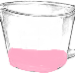  to | Puppies only
10 – 25 lbs | - kg | 1$\frac{1}{4}$ to 2$\frac{1}{3}$
25 – 50 lbs | - kg | 2$\frac{1}{3}$ to 4
50 – 75 lbs | - kg | 4 to 5$\frac{1}{3}$
75 – 150 lbs | - kg | 5$\frac{1}{3}$ to 8$\frac{1}{2}$
150 – 250 lbs | - kg | 8$\frac{1}{2}$ to 15

