**How much are these coins worth?**

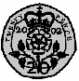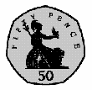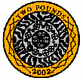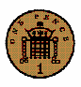

**Draw some coins that you could use to make 30p.**

2p12p

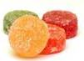

20p



2p

5p



**How much change would I get from 30p?**

12p

**12p + 8p = 20p + 10p =**

**10p + 9p = 16p + 6p =**

**16p + 4p = 28p + 9p =**

**How much are these coins worth?**





**Draw some coins that you could use to make 20p.**

**=**

**+**





**=**

**+**



**=**

**+**

**+**

**How much are these coins worth?**



**Draw some coins that you could use to make 50p.**

2p12p



20p

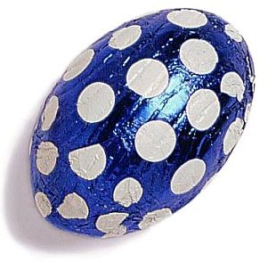

2p

5p



**How much change would I get from 50p?**

12p

**12p + 8p = 31p + 10p =**

**22p + 9p = 40p + 6p =**

**16p + 20p = 28p + 13p =**