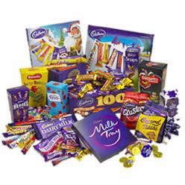
£150.50
£11.43
£ 25.55
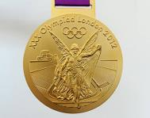
£150.50
£42.50

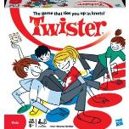
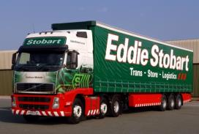
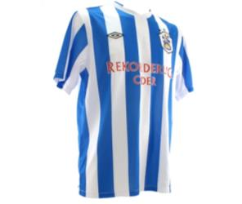
£220.00
£13.40
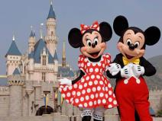
£21.20
£98.20
£25.22
£17.21
£55.50
£25.40
£42.00
£32.82

£119.98
£25.68
£19.45
£256.55
£75.60
£555.50
£18. 62
£255.50
£235.32
£130.45
£320.50
£45.85
£64.24
£176.50
£42.61
£1260.49
£120. 50
£19.99

£1920.33

£233.50

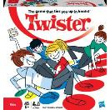

£652.20
£12.79
£68.78
£89.50
£327.60
£122.65
£258.63
£172.90
£52.09

Year 5 price comparison!
The prices seen on the pictures have been found online.
We are going to work in our maths groups. Each group has different prices for each item, found from a different website. Your group needs to find the costs for the combinations of items so that we can compare the costs at different shops later in the lesson.
- Years supply of chocolate and ipad………………………………………….
- Day as a driver’s mate in an Eddie Stobart Lorry and an ipad…………………………………
- Twister game, Ipad and day trip to Disneyland………………………………………..
- Flying lesson, twister game and rabbit…………………………………
- Dog, rabbit and twister game…………………………………..
- Flying lesson and scuba diving lesson………………………………………….
- Trip to Cliffe house and tickets to One Direction……………………..
- Year’s supply of easter eggs and Huddersfield town shirt………………
- Tickets to one Direction and a puppy………………………………………
- Olympic gold medal (replica) and twister game……………………………………..
- Now… choose which items you would like and add up the total!

Are there any prices you think are not correct? Estimate which price they should cost.
Year 5 price comparison! Red and orange
The prices seen on the pictures have been found online.
We are going to work in our maths groups. Each group has different prices for each item, found from a different website. Your group needs to find the costs for the combinations of items so that we can compare the costs at different shops later in the lesson..
- Years supply of chocolate and ipad………………………………………….
- Day as a driver’s mate in an Eddie Stobart Lorry and an ipad…………………………………
- Twister game, and day trip to Disneyland………………………………………..
- Flying lesson, and rabbit…………………………………
- Dog, and twister game…………………………………..
- Flying lesson and scuba diving lesson………………………………………….
- Trip to Cliffe house and tickets to One Direction……………………..
- Year’s supply of Easter eggs and Huddersfield town shirt………………
- Tickets to one Direction and a puppy………………………………………
- Olympic gold medal (replica) and twister game……………………………………..
- Now... choose which items you would like and add up the total!

Are there any prices you think are not correct? Estimate which price they should cost.

Item | Tuesday’s price | Reduced by | New price
Two tickets to the Huddersfield Town match
An England shirt/ One direction hoodie
A week at Alton Towers
A pet monkey
A horse riding lesson
A trip to the rainforest
A new DS game
A trip to Xscape in Castleford, including a snowboarding lesson, climbing expedition and tea at Frankie and Benny’s.

