RECTANGLES/SQUARES: I can scale up a recipe using written calculation method.
Read each question carefully, then use the recipe to calculate the quantities of each ingredients needed if I wanted to make more than 20 biscuits.
Stained glass window biscuits
Recipe makes 20 biscuits –
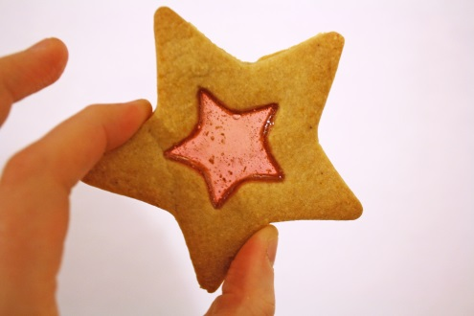
250g of boiled sweets
115g of butter
55g of caster sugar
180g of plain flour
17ml of milk
- I need to make 80 biscuits, how much butter do I need?
- If I had 110g of caster sugar, how much plain flour would I need?
- I want to make 100 biscuits, how much milk would I need?
- A) If I use 540g of plain flour, how much caster sugar do I need?
- I realise I only have 100g – How much more do I need to buy?
- I need to make 50 biscuits, how many grams of boiled sweets will I need?
- I want to make 30 biscuits, how much plain flour would I need?
- A) I’m making 100 biscuits - 1 bag of boiled sweets weighs 220g, how many bags will I need?
- One bag costs £1.50, how much will it cost to buy enough boiled sweets for 100 biscuits?
RECTANGLES/SQUARES: I can scale up a recipe using written calculation method.
Read each question carefully, then use the recipe to calculate the quantities of each ingredients needed if I wanted to make more than 20 biscuits.
Stained glass window biscuits
Recipe makes 20 biscuits –
250g of boiled sweets
115g of butter
55g of caster sugar
180g of plain flour
17ml of milk
- I need to make 80 biscuits, how much butter do I need?
- If I had 110g of caster sugar, how much plain flour would I need?
- I want to make 100 biscuits, how much milk would I need?
- A) If I use 540g of plain flour, how much caster sugar do I need?
- I realise I only have 100g – How much more do I need to buy?
- I need to make 50 biscuits, how many grams of boiled sweets will I need?
- I want to make 30 biscuits, how much plain flour would I need?
- A) I’m making 100 biscuits - 1 bag of boiled sweets weighs 220g, how many bags will I need?
- One bag costs £1.50, how much will it cost to buy enough boiled sweets for 100 biscuits?

