The Snack Shack

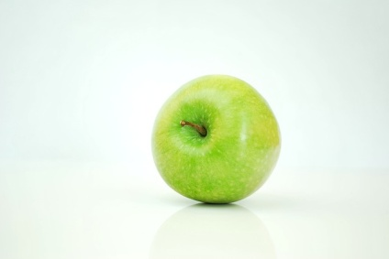
choc ice £1.29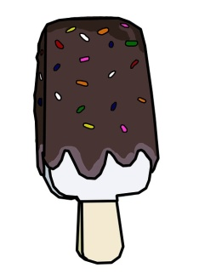 apple 47p hot chocolate £1.09 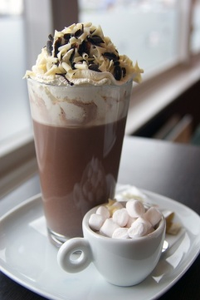
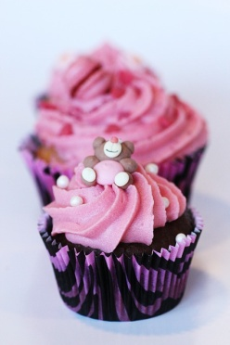 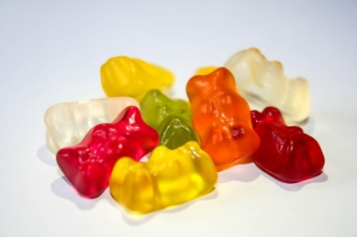 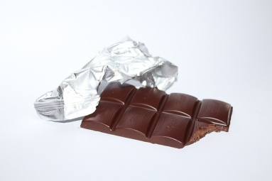 chocolate 55p
cup cake 79p sweets 63p per packet

The Snack Shack

choc ice £1.20 apple 50p hot chocolate £1.10
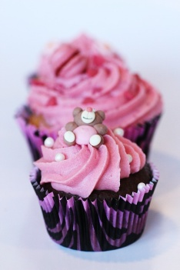
Cup cake 70p sweets 50p per packet chocolate 60p

Lucas buys 3 choc ices and 3 apples. How much change will he have if he pays with a £10 note? | Woody buys 2 choc ices and a cup cake. How much change will he have if he pays with a £10 note? | You have £3 and decide to buy three items in the Snack Shack. What three items do you buy? How much so you spend? How much change do you have?
Ella buys one of everything. How much does she spend? How much change will she have left from £10? | Eve buys 3 apples and 2 chocolate bars. She pays with a £10 note. How much change will she have? | Thomas buys 2 cup cakes and 2 hot chocolates. How much change will he have from £10?
The teachers buy 10 bars of chocolate, 5 cup cakes and 6 hot chocolates. how much money do they have left if they started with £20 | You have £20. What is left if you buy 3 choc ices and 2 packets of sweets? | Tia has £20. She buys an apple, a bar of chocolate. She buys Ella a choc ice and a packet of sweets and for Thomas she buys 2 packets of sweets. How much money does she have left?
You have £20. How much money would be left if you brought 5 cup cakes and 2 hot chocolates? | How much are 6 cup cakes? If you pay for them with a £20 note, how much money will you have left? | How many hot chocolates can you buy with £20. How much would you spend? How much would you have left?

