Time Patterns Challenge

1. Write the missing time in the sequence:
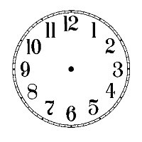

2. Write the missing time in the sequence:

3. Write the missing time in the sequence:

4. Write the missing time in the sequence:

5. Write the missing time in the sequence:

Digital Time Challenge

1. Write the missing time in the sequence:

11:30
10:30
9:30
:
7:30

2. Write the missing time in the sequence:

3:15
3:00
:
2:30
2:15

3. Write the missing time in the sequence:

:
8:50
8:40
8:30
8:20

4. Write the missing time in the sequence:

1:10
1:05
1:00
12:55
:

5. Write the missing time in the sequence:

7:05
:
6:25
6:05
5:45

