WORD PROBLEMS
using all four operations
1a. Angus saved £45.21. He brought a pair of jeans for £18.75. How much does he have left?
1b. How much does he know need to save so that he has £100 for his holidays?

2a. For her birthday Macy was given £37.00. She had saved £51.98 at Christmas. How much does she have altogether?
2b. Each week, Macy is given £4.50 pocket money. She saves this for 7 weeks. How much does she save? If she adds this to her birthday and Christmas money how much does she have altogether?

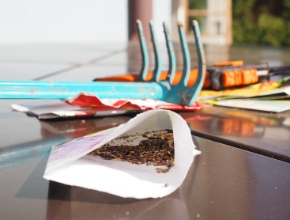
3a. Ethan has 5 plant pots. In each pot he plants 44 seeds. How many seeds does he plant?
3b. Unfortunately 10% of the seeds do not grow. How many seeds do grow?
3c. He shares the growing seeds equally with his sister. How many seeds do they have each?

4a. Every day Jennifer gives her dog 4 doggy treats. How many doggy treats does Jennifer give her dog in a week?
4b. How many doggy treats will the dog have in the May?
4c. If the doggy treats come in bags of 148. How many days will a doggy bag last?

