Problems that give rise to remainders. Can you work out what to do with the remainder?
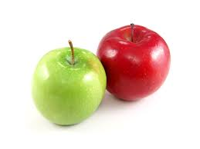
- There are 6 apples in a bag. The cook needs enough apples to feed 40 children. How many bags must the cook buy?

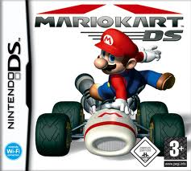
- John wants to buy a computer game costing £3.75. If he saves 50p a week, how many weeks will he need to save for before he can afford the game?

- Mr Abey wants to take 25 children to a football match. Parents have volunteered their cars. Each car can take up to 4 children. How many cars will he need to transport all the children?

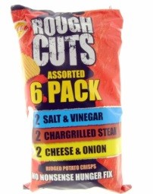
- Mrs Brownlow is giving her class a party! She has 28 in the class. Crisps come in big bags of 6. How many ‘big bags’ will she need to ensure all children get a bag of crisps?

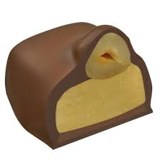
- A chocolate company has made 65 limited edition chocolates. They wish to pack them 4 to a box. How many full boxes can they make? How many chocolates will be left over?
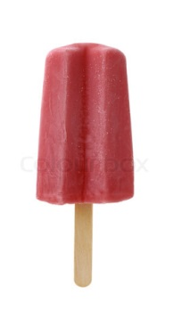
- A company packs ice lollies into boxes of 6. Each box has 3 strawberry and 3 blackcurrant lollies. They have made 50 strawberry and 50 blackcurrant lollies.
How many full boxes can they make?

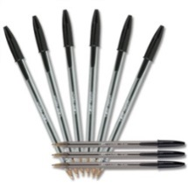
- The office wish to buy new pens for each child in year 4! Pens come in boxes of 8. There are 84 children in year 4. How many boxes will the office need to buy? How many pens will be left over?

- Mrs Thomas is throwing a party! She wants 150 balloons! Balloons come in bags of 12. How many bags will she need?
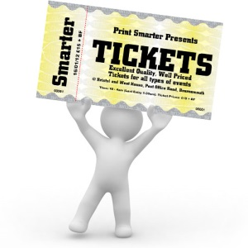
- The school is putting on its annual summer production. They wish to invite 375 people. Ticket books contain 30 tickets. How many books will they need to make sure they have enough tickets for all?
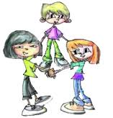
- A teacher wants her class to get in to groups of 3. She has 34 in the class. How many children will not be able to form a group of 3?

