A Crocodile is Longer Than Me

A crocodile is longer than me
A crocodile is longer than me
Hey, guess what!
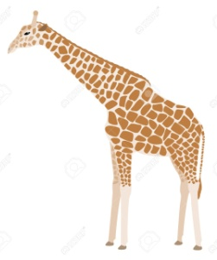
A crocodile’s a lot
A lot, lot longer than me

A brown giraffe is taller than me
A brown giraffe is taller than me
Hey, guess what
A brown giraffe’s a lot
A lot, lot taller than me
A little frog is shorter than me
A little frog is shorter than me
Hey, guess what!
A little frog’s a lot
A lot, lot shorter than me
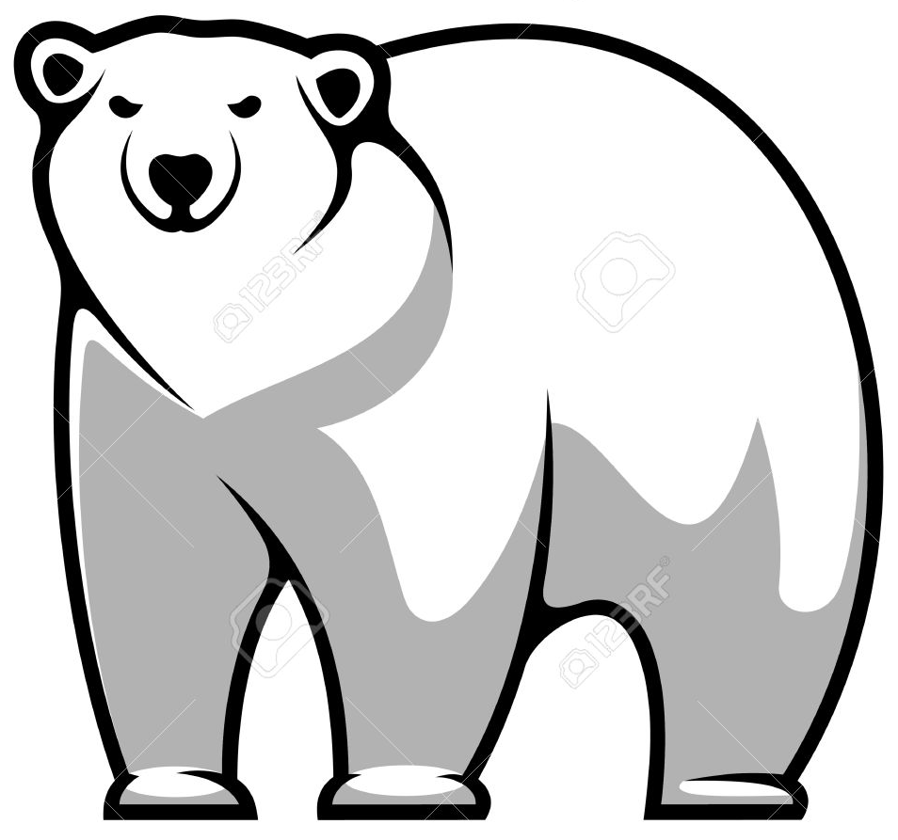
A polar bear is wider than me
A polar bear is wider than me
Hey, guess what!
A polar bear’s a lot
A lot, lot wider than me

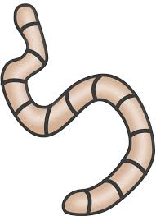
A wiggly worm is narrower than me
A wiggly worm is narrower than me
Hey, guess what!
A wiggly worm’s a lot
Lot, lot narrower than me
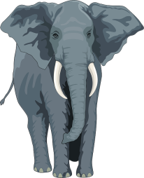
An elephant is heavier than me
An elephant is heavier than me
Hey, guess what!
An elephant’s a lot
Lot, lot heavier than me

A butterfly is lighter than me
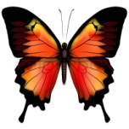
A butterfly is lighter than me
Hey, guess what!
A butterfly’s a lot
Lot, lot lighter than me

