A classroom display that had unexpected impact
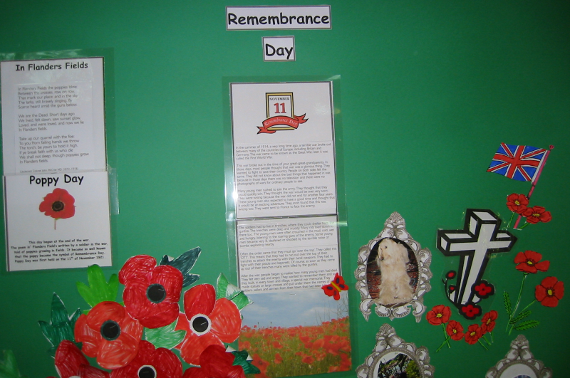

A few years ago, I was teaching 5/6-year-old students about Remembrance Day, also known as Poppy Day or Veterans Day. I explained to the class that we use this day to remember and honor soldiers who died in battles past and present.
Twenty beaming little faces looked at me, and we all jointly sat on the carpet used during Circle Time, an area that felt appropriate for this lesson, which deals with the difficult subject of death.
During the lesson, one of the boys raised his hand slowly to ask a question. Ms. Lotter, he said, “Why do we have to remember people who we do not even know? Why can’t we remember someone we know?”
I asked the child if he would like to explain who he would like to remember. “That white cross with the red flowers around it reminds me of my mommy,” he said.
I had met both his parents, and I knew there was no record of a parent’s death in the child’s personal file. So I said, “But your mommy and daddy are both at home.”
He said, “My real mommy is in a box, and on her box she has a white cross and red flowers, just like the ones on the wall.” This reminded me that his written workbooks had drawings that I hadn’t understood--of a cross and flowers and a child waving at a departing airplane.
I printed a copy of a picture frame for each child to take home with them that day, requesting them to place the picture of a pet or family member they had lost in the frame and to return it to class the following day. Animals were included since it was possible that some of the students had not lost any family members at all. We then revised the memorial wall to honor not only soldiers but also the students’ own departed loved ones.
When the parents of the boy who had lost his mother came to pick him up at the end of the school day, I showed them the drawings in their son’s book and told them what had happened in class that day. Then they told me tearfully that his birth mother had died and it was not customary for a child of his age to attend a funeral. Therefore, the mothers body had been flown to the city where her parents lived for burial.
The next day we continued the lesson with a candle for each child and a Tibetan bell. Each student was to light the candle and chime the Tibetan bell to invoke the spirit of each of the students’ departed loved ones.
The students suggested that the boy who lost his mother should go first. After lighting his candle and sounding the bell, he told the class, “You know. Ms. Lotter, my mommy often comes to sit on my bed and speaks to me at nighttime.” I asked him how his mommy communicated with him. “Ms. Lotter,” he said, “she does not speak with a voice. I look at her, and she looks at me. I see her heart and she sees mine. She speaks with her heart, and in my head I hear what she says.”
Another child stood up and said, “Yes, Ms. Lotter, we will one day no longer need to use our voices. All we would need to do is look at each other’s hearts, and then we will know what is being said.”

Copyright 2015 by Maria Elizabeth Lotter

