**L.O. Can I use an atlas to find different countries?**

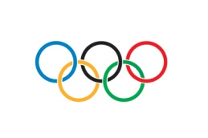**Olympic Countries Detective**

**Read the clues carefully.**

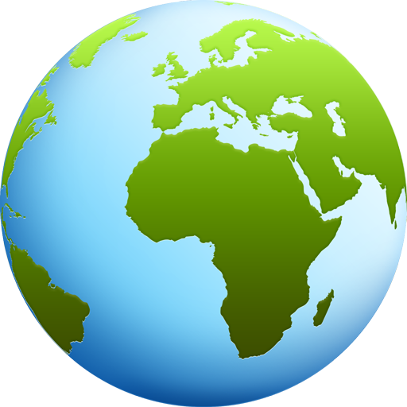**Use an atlas to check these facts.**

**Glue the correct flag in the box.**

1. This country is in Asia.

It is made up of 3 islands.

People here speak Japanese.

Its flag is red and white.

1. This country is the largest in the world.

The Arctic Ocean is to the North of this country.

Its flag is white, blue and red.

1. This country is in Europe.

It is shaped like a boot.

Its flag is white, green and red.

1. This country is the 3rd largest in the world.

It has Canada to the North and Mexico to the South.

It has hosted the Olympic Games twice.

Its flag is red, white and blue.

1. This country is in Asia.

To the West of this country is China.

To the East of this country is Japan.

Its flag is white, black, red and blue.

1. This country is not very far from the United Kingdom.

It is part of Europe.

The South of this country almost reaches to Africa.

Its flag is red and yellow.

1. This country is the largest in South America.

Its coast is on the Atlantic Ocean.

Its flag is green, blue and yellow.

1. This country is South of the USA.

To the West of this country is the Pacific Ocean.

Its flag is white, green and red.

1. This is the furthest South country in Europe.

It has hundreds of small islands around its coast in the Mediterranean Sea.

The first ever Olympic Games were held here.

Its flag is blue and white.

1. This large country is a part of Asia.

People here speak the Mandarin language.

Its flag is red and yellow.

1. This country is the 2nd largest in the world.

To the south of this country you will find the USA.

This country has the longest coastline in the world!

Its flag is white and red.

1. This country in Europe is made up of England, Wales,

Scotland and Northern Ireland.

The capital city of this country is London.

Its flag is red, white and blue.

1. This country has sea all the way around it.

It does not border any other countries.

It is the only country where kangaroos live in the wild.

Its flag is red, white and blue.

|  |  |  |  |  |
| --- | --- | --- | --- | --- |
| **Flag of ItalyItaly** | Flag of Germany  **Germany** | Russian flag  **Russia** | [Flag ofCanada]  **Canada** | [Australian flag]  **Australia** |
| [Flag of China]  **China** | [National flag of Mexico (Bandera Nacional Mexicana). By Juan Manuel Gabino Villascán]  **Mexico** | [Flag of Greece]  **Greece** | [U.S. flag]  **USA** | [Spain]  **Spain** |
| [South Korean flag]  **South Korea** | [Japan]  **Japan** | Brazil  **Brazil** |  |  |

|  |  |  |  |  |
| --- | --- | --- | --- | --- |
| **Flag of ItalyItaly** | Flag of Germany  **Germany** | Russian flag  **Russia** | [Flag ofCanada]  **Canada** | [Australian flag]  **Australia** |
| [Flag of China]  **China** | [National flag of Mexico (Bandera Nacional Mexicana). By Juan Manuel Gabino Villascán]  **Mexico** | [Flag of Greece]  **Greece** | [U.S. flag]  **USA** | [Spain]  **Spain** |
| [South Korean flag]  **South Korea** | [Japan]  **Japan** | Brazil  **Brazil** |  |  |

|  |  |  |  |  |
| --- | --- | --- | --- | --- |
| **Flag of ItalyItaly** | Flag of Germany  **Germany** | Russian flag  **Russia** | [Flag ofCanada]  **Canada** | [Australian flag]  **Australia** |
| [Flag of China]  **China** | [National flag of Mexico (Bandera Nacional Mexicana). By Juan Manuel Gabino Villascán]  **Mexico** | [Flag of Greece]  **Greece** | [U.S. flag]  **USA** | [Spain]  **Spain** |
| [South Korean flag]  **South Korea** | [Japan]  **Japan** | Brazil  **Brazil** |  |  |