Olympic host cities
- Copy and complete this table into your WAU books.

Olympic Year | Host City | Country | Continent | Grid reference
2016
2012
2008 | Beijing
2004 | Athens
2000 | Sydney
1996 | Atlanta
1992 | Barcelona

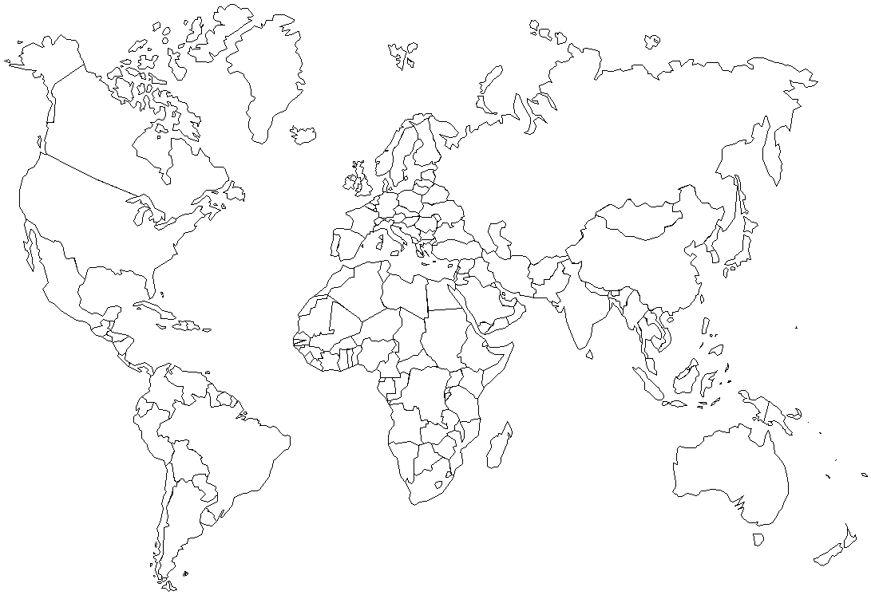
- Put the cities onto this world map. Use a red dot to mark and remember to write horizontally and give the city a capital letter.
- Cut out the map and stick into your WAU book.
- Answer the questions from the board.

- Which continents did not host any Summer Olympic games during the past 24 years?

- Why do you think this is?

- Which continent has been most popular to host summer Olympic Games in this period?

- What do you think are some of the things a city must have in order to host an Olympic Games?

