Mountain Ranges of the United States
A mountain is very big – much bigger than a hill. Sometimes, there are lots of mountains in a long line. When this happens, we call it a mountain range. A mountain range can go on for hundreds or even thousands of miles. There are three main mountain ranges in the USA. They are called the Appalachians, the Rocky Mountains and the Sierra Nevada Mountains. They are all different to each other in many ways. |  | 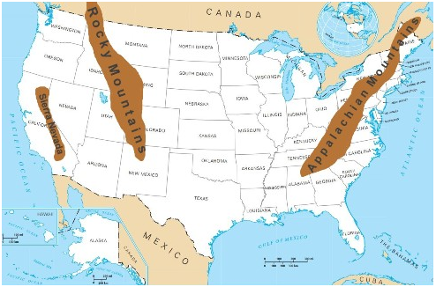
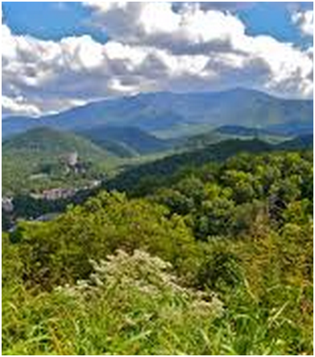 | The Appalachian Mountains  The Appalachians are on the east side of the USA. They run along for about 1,500 miles. They are the oldest mountains in America – about 480 million years old. The highest mountain in the Appalachians is Mount Mitchell which is 6,684 feet tall. A lot of these mountains are covered in forest. Pine, Spruce, Birch and Maple trees grow on them. Many animals live in the Appalachians because there are so many trees. There are squirrels, wolves, deer and black bears. When settlers first moved to the USA, they used wood from the trees for fuel and to build with.
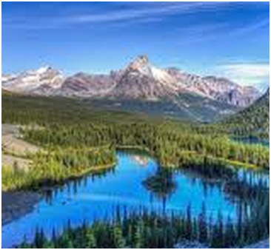 | The Rocky Mountains  The Rockies are the longest mountain range in North America and are between the Appalachians and the Sierra Nevada. They are over 3,000 miles long. The highest mountain in the Rockies is Mount Elbert in Colorado which is 14,440 feet high. There are warm, rainy Summers and cold, snowy Winters in the Rocky Mountains. There are forests of Spruce, Pine, Oak, Juniper, and Fir trees. Animals that live there include bighorn sheep, grizzly bears, black bears, coyotes, elk, and deer. Hunters used to trap animals there because their fur was very valuable.
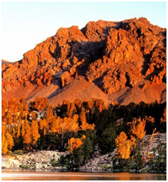 | The Sierra Nevada Mountains  The Sierra Nevada Mountains are on the western side of the United States. They are 400 miles long. The highest mountain in the Sierra Nevada Mountains is Mount Whitney at 14,505 feet. The largest trees in the world grow there. They are called Giant Sequoia trees and they can grow up to 270 feet tall. The animals which live there are rabbits, hares and squirrels. Also, wild cats live there but unless you are very patient, you are unlikely to spot them because they are shy. About 150 years ago, thousands of people rushed to these mountains when gold was discovered there.

