Year 4 Area & Perimeter

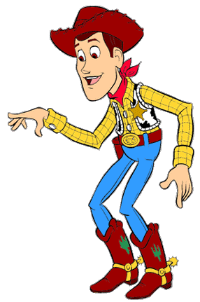LO: To be able to find the area and perimeter of compound shapes.

I need to round up the cows in a pen. Look at these pens. I need to know how long the fence (or perimeter) is and how big they are (or area) to see how many cows they will hold, can you help?

5m

B)

A)

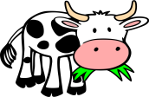

7m

2m

9m

5m

7m

7m

15m

6m

5m

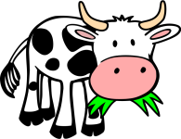

12m

12m



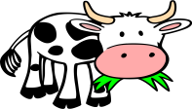

C)

4m

D)

6m

4m

6m

6m

10m

2m

2m

5m

5m

14m

5m

4m

18m

5m

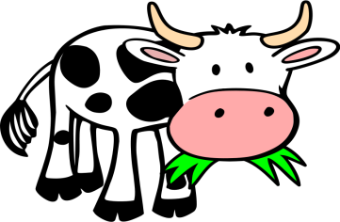

6m



5m

7m

10m

F)

E)

8m

12m

8m

6m

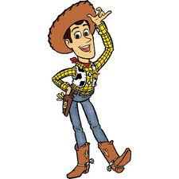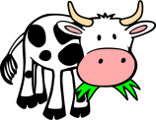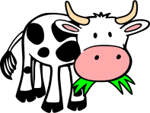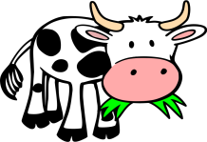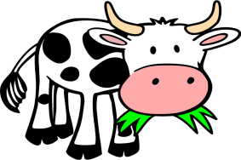

55m

20m

15m

25m

6m

8m

10m

6m

12m

6m

20m

100m

25m

20m

18m

35m

10m

Make sure you include all the measurements. Some are missing!

12m

14m

18m

32m

12m

6m

13m

4m

17m

I)

J)

H)

G)

6m