We have been measuring liquids (capacity/volume) in ml and l (and cl).
There are 1000ml in one litre (l). There are 100cl in one litre (l).
Please read the labels on cartons or bottles at home and write down how much fluid they contain. State whether this is MORE or LESS than 1 litre.

Container or Fluid | Volume in ml, cl or l | Is it MORE or LESS than 1 litre?
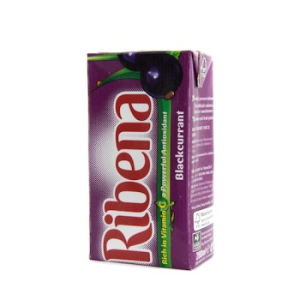 | 200ml | LESS than 1 litre

Extra space…
Container or Fluid | Volume in ml, cl or l | Is it MORE or LESS than 1 litre?

