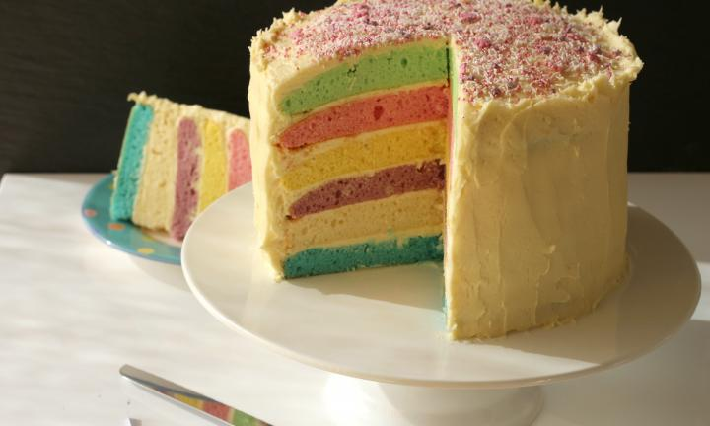
How to make a fraction cake

Ingredients
The cake
375g butter or margarine
375g caster sugar
375g self raising flour
6 eggs
3 tablespoons water
Food colouring (4 different colours)

The icing
375g butter
750g icing sugar
Food colouring

- Your group of 8 people first needs to split itself into quarters!
- Now there are _______ groups. 1 group will be working on the icing for the cake, the rest will make the cake itself.
For the cake
- First, all of you need to find a third of the cake ingredients and weigh them out. Finding a third is the same as dividing by 3 or sharing between 3.
- Once you have weighed out all your ingredients, mix them all together! Stir really well, until all the ingredients are thoroughly combined.
- Now each group needs to split their mixture in half! To each half add a couple of drops of food colouring.
- Now put each different coloured mixture into a different cake tin.
- Bake for 15 – 20 mins at 180˚ C or gas mark 4.
- Turn out onto a cooling rack.

For the icing
- Beat the butter with half of the icing sugar until it is smooth.
- Add the rest of the icing sugar and the milk and beat until the mixture is creamy.
- Now split the mixture into sixths! Add a couple of drops of food colouring to each bowl so you have 6 different colours of icing. You will need to mix some colours to make new ones.
- When the cake is cool, you can spread the buttercream on top of each layer so that all the layers stick together.

Now your fraction cake can be cut into more fractions so that everyone has a piece.
What fraction of the whole cake is the blue layer in your piece?

