CIRCLES WORD PROBLEMS

Work out how much each person spends?
1. David buys a wheelbarrow and a spade.
2. Harriet buys a ton of gravel and an apple tree.
3. Bobby buys a bench and a shed.
4. Nathan buys a bench and an apple tree.
5. Holly buys a wheelbarrow and a shed
Work out how much each item costs in the sale.
6. Wheelbarrow – SAVE £47
7. Spade – SAVE £28
8. Gravel – SAVE £69
9. Apple tree – SAVE £161
10. Bench – SAVE £159
11. Shed – SAVE £396

CIRCLES WORD PROBLEMS

Work out how much each person spends?
1. David buys a wheelbarrow and a spade.
2. Harriet buys a ton of gravel and an apple tree.
3. Bobby buys a bench and a shed.
4. Nathan buys a bench and an apple tree.
5. Holly buys a wheelbarrow and a shed
Work out how much each item costs in the sale.
6. Wheelbarrow – SAVE £47
7. Spade – SAVE £28
8. Gravel – SAVE £69
9. Apple tree – SAVE £161
10. Bench – SAVE £159
11. Shed – SAVE £396

CIRCLES WORD PROBLEMS

Work out how much each person spends?
1. David buys a wheelbarrow and a spade.
2. Harriet buys a ton of gravel and an apple tree.
3. Bobby buys a bench and a shed.
4. Nathan buys a bench and an apple tree.
5. Holly buys a wheelbarrow and a shed
Work out how much each item costs in the sale.
6. Wheelbarrow – SAVE £47
7. Spade – SAVE £28
8. Gravel – SAVE £69
9. Apple tree – SAVE £161
10. Bench – SAVE £159
11. Shed – SAVE £396

CIRCLES WORD PROBLEMS

Work out how much each person spends?
1. David buys a wheelbarrow and a spade.
2. Harriet buys a ton of gravel and an apple tree.
3. Bobby buys a bench and a shed.
4. Nathan buys a bench and an apple tree.
5. Holly buys a wheelbarrow and a shed
Work out how much each item costs in the sale.
6. Wheelbarrow – SAVE £47
7. Spade – SAVE £28
8. Gravel – SAVE £69
9. Apple tree – SAVE £161
10. Bench – SAVE £159
11. Shed – SAVE £396

CIRCLES WORD PROBLEMS

Work out how much each person spends?
1. David buys a wheelbarrow and a spade.
2. Harriet buys a ton of gravel and an apple tree.
3. Bobby buys a bench and a shed.
4. Nathan buys a bench and an apple tree.
5. Holly buys a wheelbarrow and a shed
Work out how much each item costs in the sale.
6. Wheelbarrow – SAVE £47
7. Spade – SAVE £28
8. Gravel – SAVE £69
9. Apple tree – SAVE £161
10. Bench – SAVE £159
11. Shed – SAVE £396

CIRCLES WORD PROBLEMS (NO BORROWING)

Work out how much each person spends?
1. David buys a wheelbarrow and a spade.
2. Harriet buys a ton of gravel and an apple tree.
3. Bobby buys a bench and a shed.
4. Nathan buys a bench and an apple tree.
5. Holly buys a wheelbarrow and a shed
Work out how much each item costs in the sale.
6. Wheelbarrow – SAVE £21
7. Spade – SAVE £53
8. Gravel – SAVE £34
9. Apple tree – SAVE £145
10. Bench – SAVE £113
11. Shed – SAVE £351

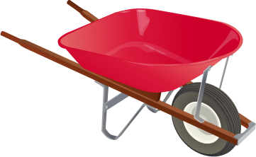 | £132
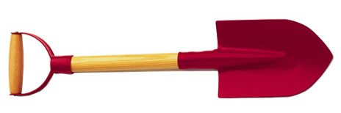 | £84
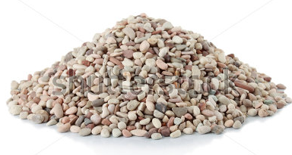 | £147
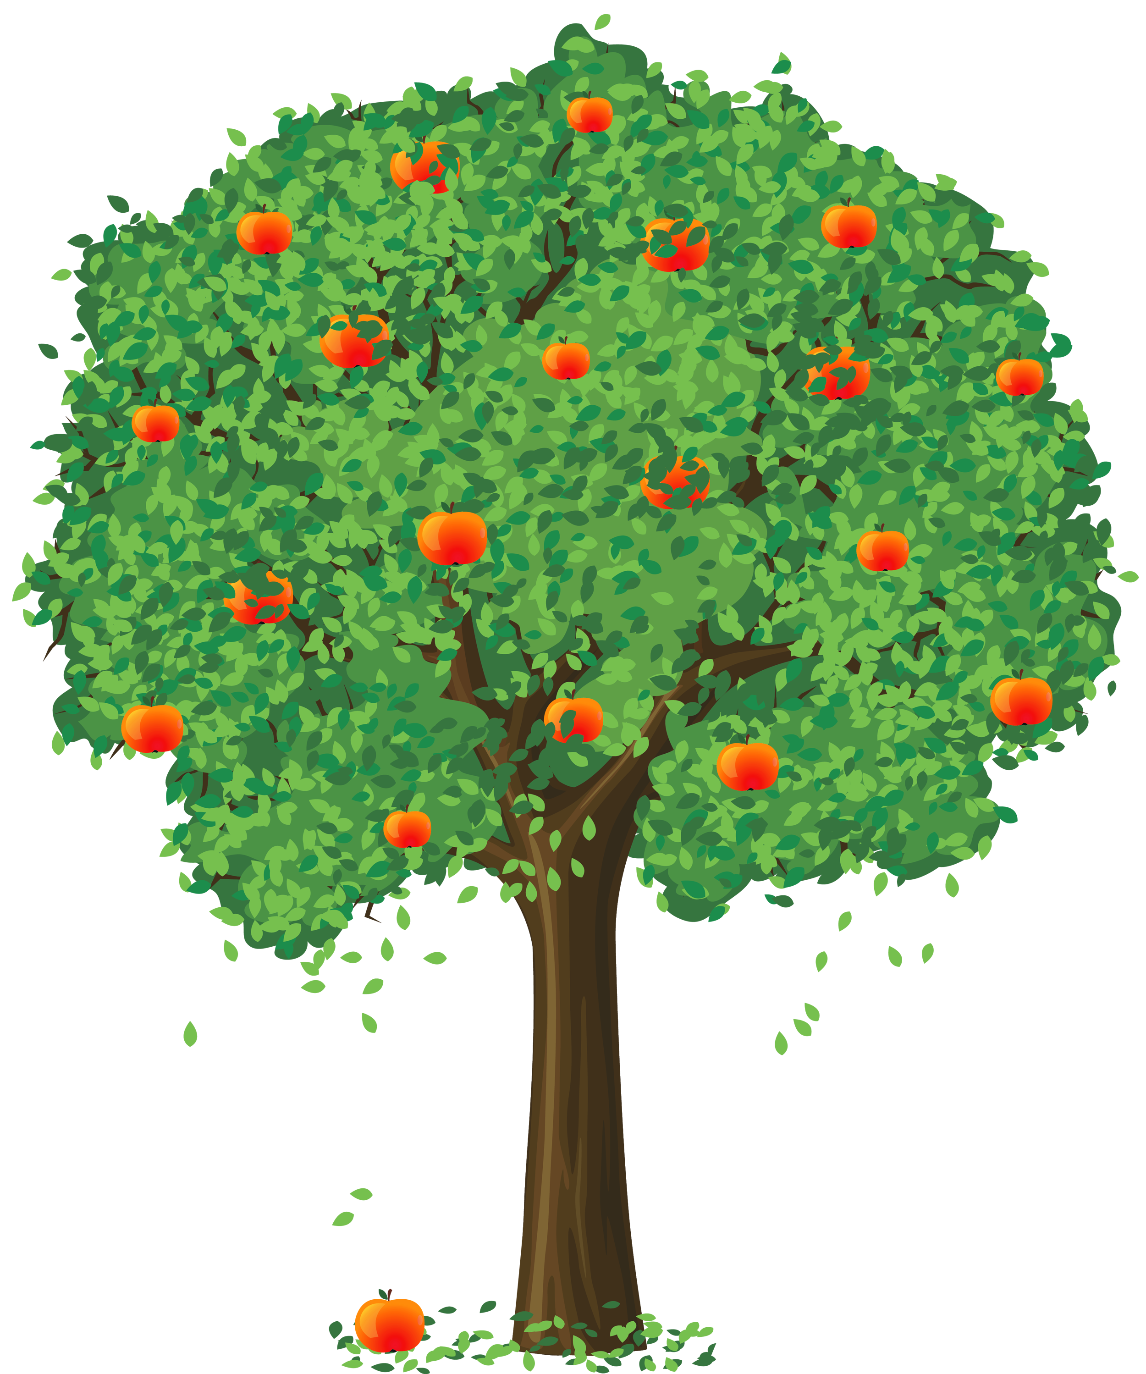 | £259
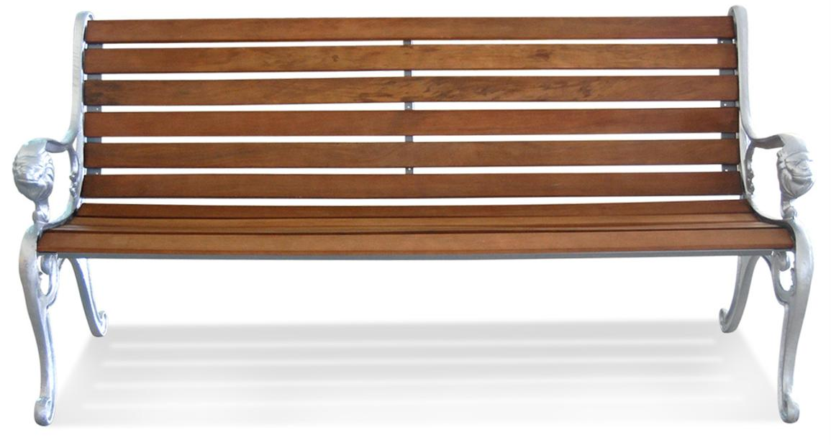 | £316
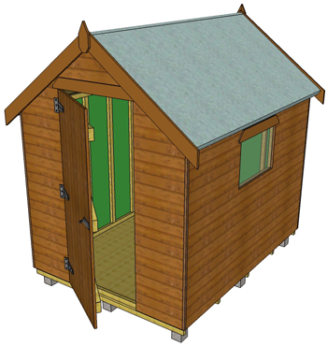 | £672

£132
£84
£147
£259
£316
£672

