WALT read scales accurately.
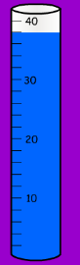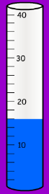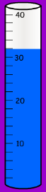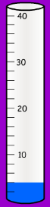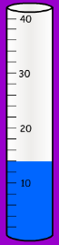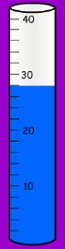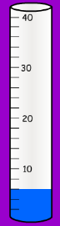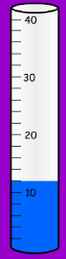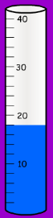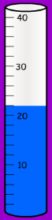
1)____ml 2)____ml 3)___ml 4)____ml 5)____ml 6)____ml 7)____ml 8)____ml 9)____ml 10)___ml

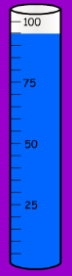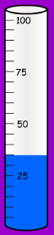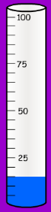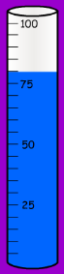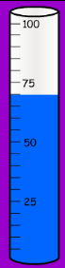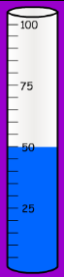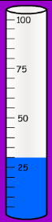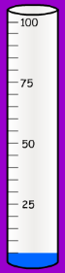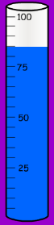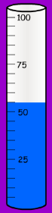
11)___ml 12)___ml 13)___ml 14)___ml 15)___ml 16)___ml 17)___ml 18)___ml 19)___ml 20)___ml

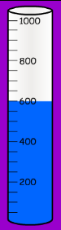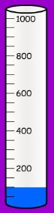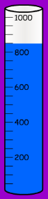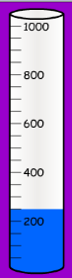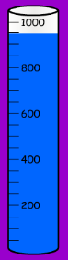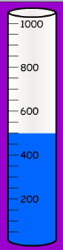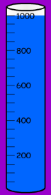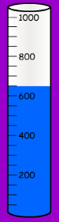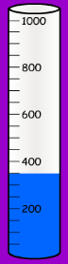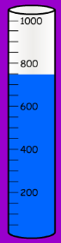
21)___ml 22)___ml 23)___ml 24)___ml 25)___ml 26)___ml 27)___ml 28)___ml 29)___ml 30)___ml

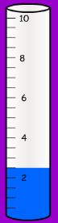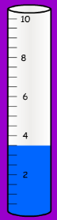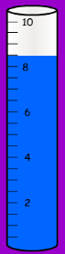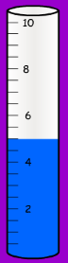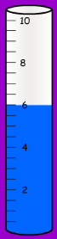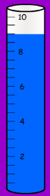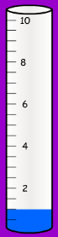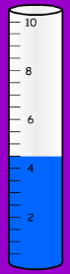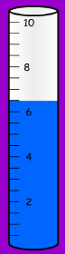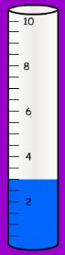
31)___ml 32)___ml 33)___ml 34)___ml 35)___ml 36)___ml 37)___ml 38)___ml 39)___ml 40)___ml

WALT find the difference between two amounts of liquid.
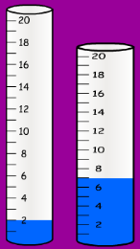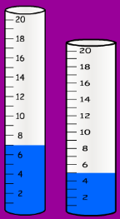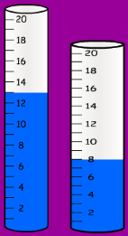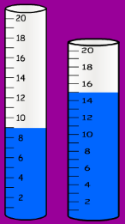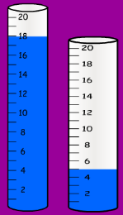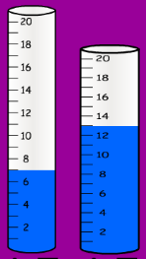
1)Difference =__ml 2)Difference =__ml 3)Difference =__ml 4)Difference =__ml 5) Difference =__ml 6) Difference =__ml

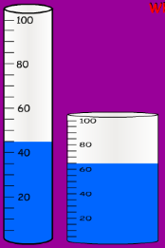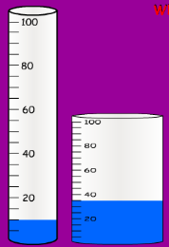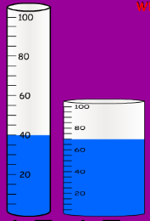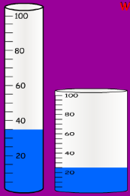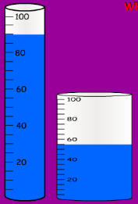
7) Difference =__ml 8) Difference =__ml 9) Difference =__ml 10) Difference =__ml 11) Difference =__ml

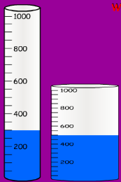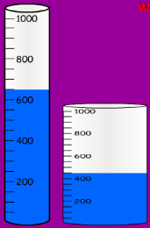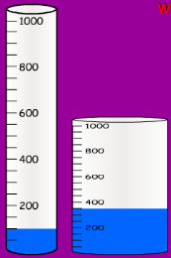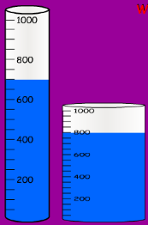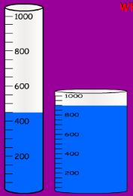
12) Difference =__ml 13) Difference =__ml 14) Difference =__ml 15) Difference =__ml 16) Difference =__ml

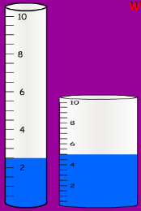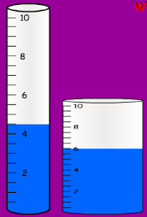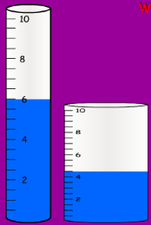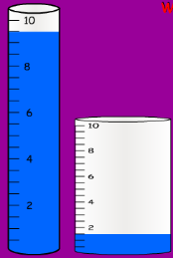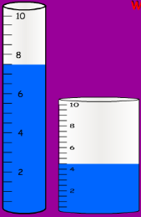
17) Difference =__ml 18) Difference =__ml 19) Difference =__ml 20) Difference =__ml 21) Difference =__ml

WALT find the difference between capacities, including decimals.
1) Difference =__ml 2) Difference =__ml 3) Difference =__ml 4) Difference =__ml 5) Difference =__ml

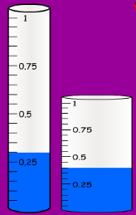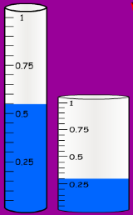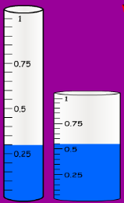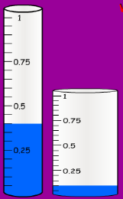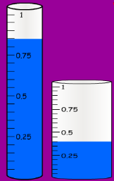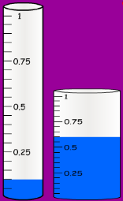
6) Difference =___l 7) Difference =___l 8) Difference =___l 9) Difference =___l 10) Difference =___l 11) Difference =___l

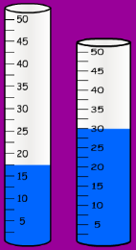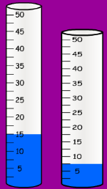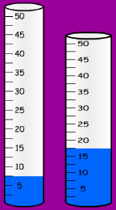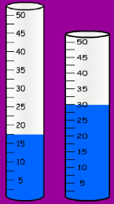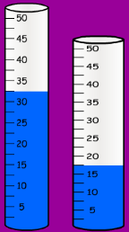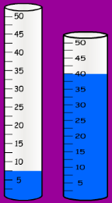
12)Difference =__ml 13) Difference =__ml 14) Difference =__ml 15) Difference =__ml 16) Difference =__ml 17) Difference =__ml

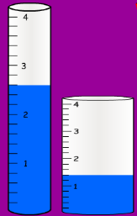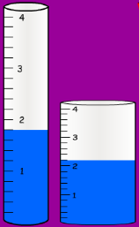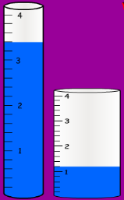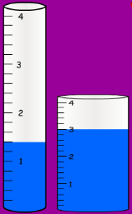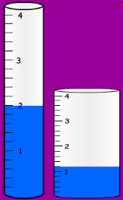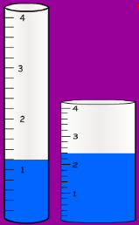
18) Difference =___l 19) Difference =___l 20) Difference =___l 21) Difference =___l 22) Difference =___l 23) Difference =___l

