Shape
Below is a list of prefixes (the start of a word) and what they mean
Uni = one
Bi = two
Regular
Triangle
Tri = three
Regular

Quadrilateral
Quad = four
Regular
Pentagon
Penta = five
Regular
Hexagon
Hexa = six
Heptagon
Regular
Hepta = seven
Octa = eight
Regular
octagon

Regular
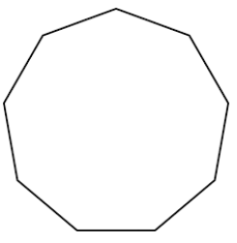
Nona = nine
Nonagon
Regular
Decagon
Deca = ten
Dodecahedron
Dodeca = twelve
Regular

