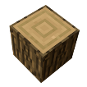 | Your next job is to build a pickaxe but you need double the amount of wood you just punched down. How much do you need altogether? | 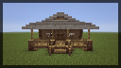 | You find 12 sheep to help make your bed. You only need half the amount of sheep. How many do you need?
You need to punch down a tree; you get 5 pieces of wood then 6 pieces of wood. How many all together? | 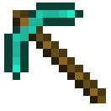 | It starts getting dark at 7pm… it is now 5pm… how long do you have left to build your shelter? |  | It is now nearly dark and your house is finally built but you need to find foodstuffs. You find 3 watermelon, 4 apples and a potato. How much is that?
 | You now need to make your crafting table, you need 9 pieces of wood but you break 5 of them. How many do you have left? |  | There are some creatures heading your way. You need to make 2 torches. How much more coal and cobblestone do you need?
Start |  | You need to dig for coal and cobblestone to make more weapons. You find 10 pieces of coal and 5 cobblestones. You need 10 cobblestones to make your weapon, how many more do you need? |  | Finish

You have just landed in a new Minecraft world… Your job is to get dig and build your way through to make sure you build shelter before dark! Remember to use positional language when guiding your partner to the next puzzle.

