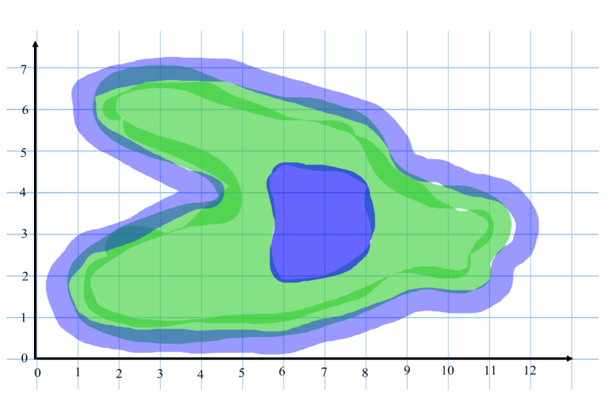Name: _________________ **Treasure Island**

The island has many palm trees growing on it. Put a ‘P’ for each palm tree at the following coordinates:

(4,2) (10,3) (3,6) (7,5)

There is a patch of quick sand on the island, Put a ‘Q’ at location (2,6)

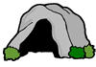C:\Users\John\AppData\Local\Microsoft\Windows\Temporary Internet Files\Content.IE5\3W883FS4\MC900233594[1].wmfC:\Users\John\AppData\Local\Microsoft\Windows\Temporary Internet Files\Content.IE5\3W883FS4\MC900233594[1].wmfSharks patrol around the island in the sea. Put an ‘S’ at the following points: (11,6) (12,1) (1,4)

Write the coordinate of the following objects:

( , )

( , )

( , )

( , )

( , )