LI: I can recognise and use whole, half and quarter turns, both clockwise and anticlockwise; know that a right angle represents a quarter turn

Start
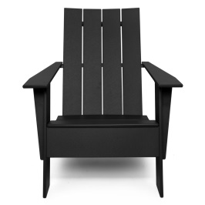
Start
Start
Start

LI: I can recognise and use whole, half and quarter turns, both clockwise and anticlockwise; know that a right angle represents a quarter turn

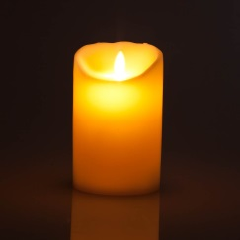
Start | Half turn | Quarter turn clockwise | Full turn
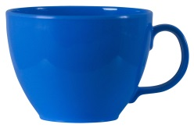
Start | Quarter turn anti-clockwise | Half turn | Full turn
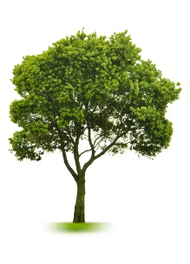
Start | Quarter turn clockwise | Full turn | Half turn
Start | Full turn | Half turn | Quarter turn anti-clockwise
Start | Half turn | Full turn | Quarter turn clockwise

