I have 16 bananas and I give 8 to the monkeys. How many do I have left?

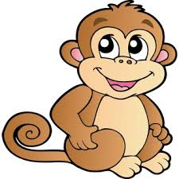 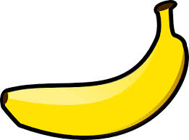

Tom has 15 cakes. He give 4 to Sarah and 3 to Bill. How many have they got altogether? 

I eat 7 apples at snack time and 8 apples at lunch time. How many apples have I eaten altogether?

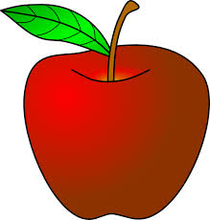

There a 14 children on the bus. Another 7 children get on. How many children are there now on the bus?

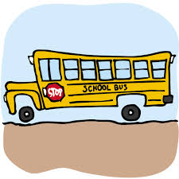

Sarah has 5 pencils and she is given 7 more. How many does she have altogether?

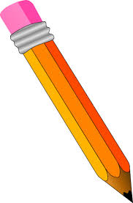

An elephant weighs 12 bricks. A mouse weights 3 bricks. What is the difference between their weights?

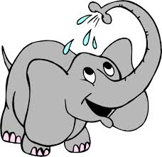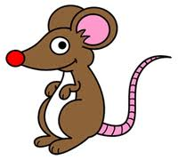

I have 8 sweets. I give 4 away. Now how many sweets do I have left?



Claire has 3 books. Tom gives her 6 more. How many books has she got altogether?

