Circle Time Ideas
Mindfulness, Health, and Wellness

Commitment to Save
The
Environment

Water
I will try to:
- Only fill the kettle with as much water as necessary for immediate use
- Run only full loads of laundry
- Take a shower instead of a bath when possible
- Turn off the tap when brushing my teeth
- Use water sparingly

Waste
I will try to:
- Use a recycle bin, when available, for all recyclable materials
- Think before I throw anything away
- Limit trashing of food waste by feeding left over rice, nuts, fat, bread, and meat to crows, birds, and outdoor animals where appropriate
- Take a reusable bag with me when I go shopping
- Install a compost bin in the garden

Energy
I will try to:
- Install energy saving light bulbs in my home
- Turn lights off when I leave a room
- Turn my computer off when not in use
- Use the heater and air conditioner sparingly
- Use local food rather than imported food

Carbon Dioxide
I will try to:
- Take the bus when possible
- Share car journeys when possible
- Bike or walk to school if possible

CC0 Public domain

Principles and Practices for Healthy Living
Optimum Nutrition for the Brain

Our health is significantly influenced by our beliefs, emotions, environmental factors, nutrition, and exercise, all factors that have an impact on our behavior patterns, relationships, work, and school-life productivity.

Factors that contribute to health degeneration and how to create a balance:
- Nutrition, not enough water intake and sunlight – Follow a healthy diet, drink enough water daily, and ensure that you are exposed to sunlight for at least 10 to 20 minutes a day.
- Lack of exercise and physical activity – Do some form of exercise daily.
- Negative thoughts, activities, and emotions – Become a possibility thinker.
- Negative speech – Change this by making use of Switchwords and NLP (neuro-linguistic programming).

Responsible Pet Care Club

Taking care of a pet teaches children about responsibility and stimulates mental and emotional stability and growth. The teacher can give students an opportunity to share with the class their experiences with their pet on a weekly basis. These presentations will enable students to gain confidence in public speaking.

Taking care of a dog
- Feed it once or twice a day, and provide it with clean water daily.
- Wash its feeding and water bowls daily.
- Take it to the vet for regular care.
- Wash the dog’s bedding weekly.
- Bathe the dog at least once a month, and brush its teeth daily.
- Take the dog for regular walks.
- Search for tips and recipes to make your own dog food, if possible.
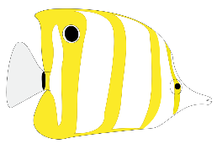
Taking care of fish
Fish make ideal pets for children and adults. Watching fish swimming around an aquarium is extremely calming and peaceful. Fish have a soothing and therapeutic effect upon the human psyche.
Public domain
- Set up an aquarium.
- Maintain and clean the tank regularly.
- Feed the fish daily.

Teaching Human Values In Circle Time
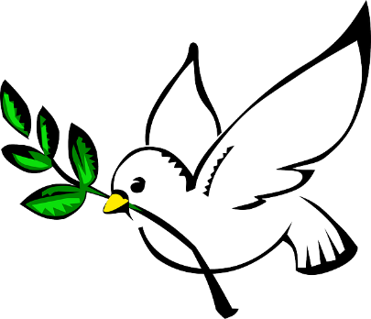
CC0 Public Domain

Excerpt from “All I Really Need To Know I Learned In Kindergarten”
By Robert Fulghum
Share everything.
Play fair.
Don’t hit people.
Put things back where you found them.
Clean up your own mess.
Don’t take things that aren’t yours.
Say you’re sorry when you hurt somebody.
Wash your hands before you eat.
Flush.

Forgiveness
Forgiving someone who has hurt our feelings is a way of giving a gift to ourselves.
When we shift from anger to forgiveness we operate from a level of wisdom.
It is important to remember that what you become angry with controls you and your life.

My Truth
I believe in myself.
I love and honor my body.
I do my personal best.
I follow instructions to the best of my ability.
I always say “I can do it”.
I make myself better.
I honor my place in society.
I honor my family.
I honor people, my community, animals, plants, and the Earth.
Miracles happen daily!
This or something better for the highest good of all now occurs!

Copyright 2015 by Maria Elizabeth Lotter

