EASIER Tip? Write them on Post – its and move them around!

bauble bells present snowflake

wreath tree reindeer holly

candle sweet manger snowman

**Can you find these anagrams?**

e t e r tree

t r e e p s n present

l e b l s bells

l a c e n d candle

l a b u b e bauble

w e s t e sweet

w o m a n n s snowman

wreath w r a t e h

snowflake n o w s k a l f e

jesus s u e j s

d r e i r e e n

snowflake w o s n k a e l f

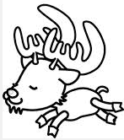

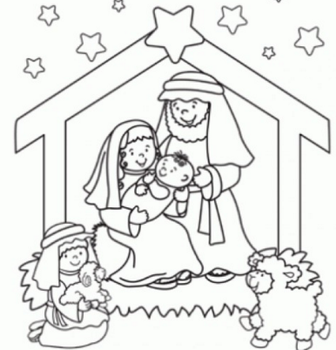





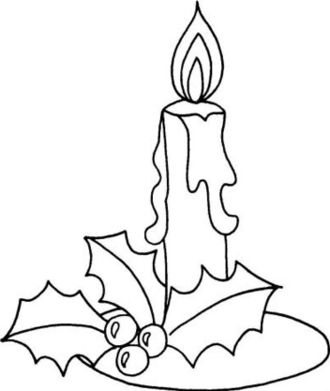

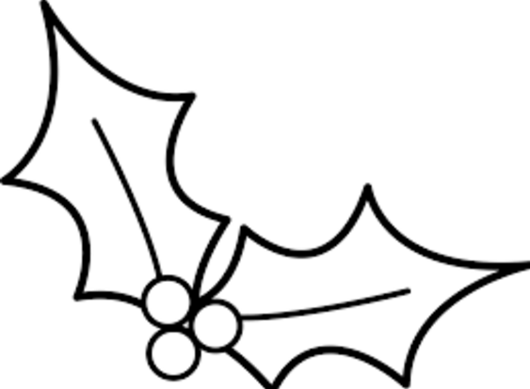

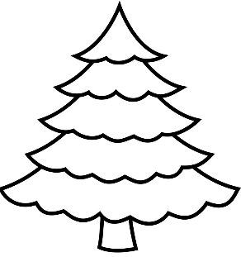

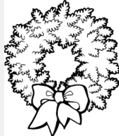

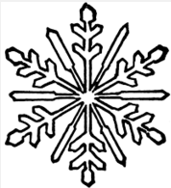

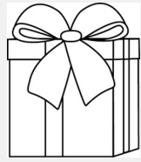

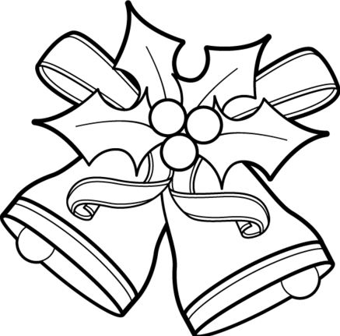

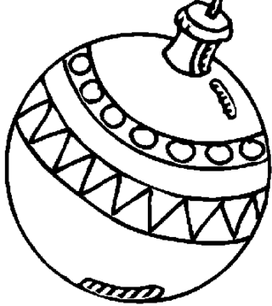

bauble bells present snowflake

wreath tree reindeer holly

candle sweet manger snowman

**Can you find these anagrams?**

**t** e e r

**p** e t r e s n

**b** e s l l

**c** a l e n d

**b** a l u b e

**e** w s t e

**s** w o n a n m

**w** r a t e h

**s** w o n w k a l f e

**j** u e s s

**r** e d i r e e n

**s** w n o k a e l f

Tip? Write them on Post – its and move them around!























