1 | OCTOPUS: Shape-shifting, invisibility  This deep sea shape-shifter is equipped with the best defenses Mother Nature has to offer. The eight-tentacled wonder hides from predators using its amazing powers of camouflage making it all but invisible.  If discovered, the wily creature spews a cloud of ink that both creates a diversion so it can flee, AND dulls its attacker's senses making it harder to track. As a last resort, the fast-swimming octopus can morph its body to squeeze through narrow cracks and crevices, or give up a limb if caught and grow a new one later. Bottom line – don't mess with it.
2 | GECKO: Anti-gravity glue grip feet  The gecko – nature’s Spiderman – has many special powers, including its own chirping language and among its defensive weapons is the ability to shed its tail should a predator latch on. The tiny lizard also has a built in feces catapult to repel attackers. But the gecko's most famous super power is anti-gravity suction toes that allow it easily to climb up vertical surfaces and even across ceilings. But it's not a sticky web that gives the gecko its power - it is microscopic hair-like strands on each toe that trigger a pull allowing the gecko to adhere to (almost) any surface. The lizard does, however, have a Kryptonite - it can't stick to Teflon!
3 | PUFFERFISH: Inflatability, deadly poison  Don't be fooled by its cute face. The pufferfish, also called the blowfish, may not blessed with speed or agility, but the clumsy fish has the miraculous skill of increasing its size by several times to intimidate predators. The fish has a stretchy, elastic stomach, and "inflates" by gulping water and air to morph into a ball. Pufferfish, is also highly poisonous. The fish contains a poison fatal to humans. In fact, one fish holds enough poison to kill 30 adult humans.
4 | CHAMELEON: Invisibility  Chameleons are in the running for best superhero costume of the animal kingdom – and they don’t even need to rush into a phone booth before making a quick change to hues of brown, black, gold, green and even pink or turquoise. The unique ability to blend in with their natural surroundings, thanks to special skin cells, makes these lizards incredibly difficult for predators to spot. Chameleons are also master climbers and have stereoscopic vision, allowing them to zero in on their prey with warp speed.
5 | CHEETAH: Speed on land  This cool cat is the fastest land mammal on earth, with the ability to go from 0 to 60 mph in just 3 seconds. Its speed, coupled with its razor-sharp eyesight, let cheetah terrorize the grasslands in which it lives hunting for prey -- and earn it the status of super beast
6 | PEREGRINE FALCON: Speed in air  Faster than a speeding bullet - you betcha! Superman's got nothing on this rad raptor. Equipped with a razor sharp beak and talons, peregrine falcons are the fastest-flying birds on earth. They mate for life, meaning the birds pair off in dynamic duos that bring death from above to their prey – bats, songbirds and ducks – at speeds of up to 200 mph
7 | SEA DRAGON: Camouflage  Is it flora or fauna? To hungry predators, it's almost impossible to pick out the well-disguised sea dragon from the plants in which it lives. The sea dragon has some of nature's most elaborate camouflage costumes. The graceful creature floats through the leafy seaweed on the ocean floor and looks just like the gently waving kelp. The willowy sea dragons live in waters off south and east Australia – and may or may not be pictured above. Like we said, flora or fauna? It's tough to tell
8 | TARSIER: Night vision  These huge, freakish eyes see all. The tasier's eyeballs are each as big as its brain and allow the tiny nocturnal primate to hunt by night. The minuscule creature also has acute hearing, thanks to its oversized ears – and is able to swivel its head 180 degrees in either direction to seek out its prey. On other words, you can run, but you can't hide

9 | PLATYPUS: Electroreception!  This awkward duck-mammal may seem an unlikely animal super hero, but don’t be fooled! The web-footed creature has an amazing sixth sense: electoreception. This power allows the platypus – which has poor vision – to detect prey by sensing electric fields generated by muscle movement. Even in a dark room wearing a blindfold and ear plugs, the platypus will hunt you down. They're also naturally packing some powerful heat: sharp venomous talons on their heels allow the platypus to deliver a toxic kick to predators in hot pursuit, so moral – keep your distance.
10 | DOLPHINS: Ultrasonic hearing  Dolphins look like they’re smiling. But it’s their way of communicating among their own pods that makes them special. Dolphins have super-developed hearing and can detect sounds at least ten times above what most humans hear – and, they hear with their teeth! Dolphin teeth function like well-tuned antenna and serve the dolphin like an internal GPS system
11 | RHINOCEROS BEETLE: Amazing strength  It's the tiny tank of the insect world. The Rhinoceros Beetle is considered the world’s strongest creature and can carry up to 850 times its own body weight. A human would have to lift about 65 tons to match the minuscule bug's might. The beetle’s name is inspired by its fierce horn – and it's not just ornamental. Like gladiators in the ring, male beetles use them to joust – may the best beetle win
12 | HUMMINGBIRD: Helicopter hover flight  If you’re planning on vanquishing a villain by air, it’d be ideal to have an army of hummingbirds by your side. Hummingbirds have wings that beat so fast – up to 90 times per second – that they can hover in mid-air. They’re also the only birds in the animal kingdom that can fly backwards. How do they get so much energy for their feats? Their diet consists of super-sweet nectar, which they must consume about every 10 minutes, as well as insects and spiders for protein. Watch out, Peter Parker.
13 | FLYING SQUIRREL: It flies!  For these tree-dwelling rodents, the sky’s really the limit. Flying squirrels don’t really fly – they glide from tree to tree. These amazing rodents have been known to glide for over 200 feet before landing. The tautness of the webbed-parachute-like membrane keeps them in the air and their tail acts as a brake.
14 | SEA CUCUMBER: Body liquefication  When the sea cucumber senses danger, it melts – literally. These oblong creatures are able to loosen or tighten their outer body armour at will – allowing them squeeze through tiny cracks and pour into narrow crevices to take shelter from predators.
15 | ELECTRIC EEL: Zaps adversaries with electric shocks  This slithery sparker is isn’t actually an eel. It’s a knifefish. The electric eel uses its current to incapacitate its prey. These shocks aren’t just tiny tingles either. An electric eel is capable of producing a 500 volt shock – enough to kill an adult human. They also use these shocks to protect themselves from predators
16 | BATS: Echolocation, hyper-healing  Besides the fact that bats are they only mammal that truly flies – they have an echolocation power that allows them to discern the layout of a pitch black room and to locate hidden prey. The bat’s wings are very thin – allowing for precise and sharp moves – they beat birds by a long shot for flight skills. The thin membrane of webbing on the wings heals quickly if torn. The bat emits a sound intended to create an echo .

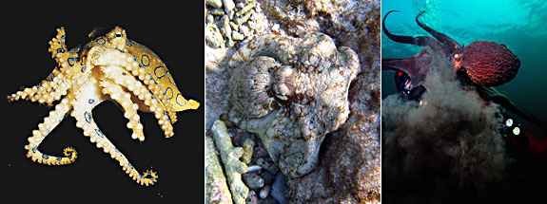 | 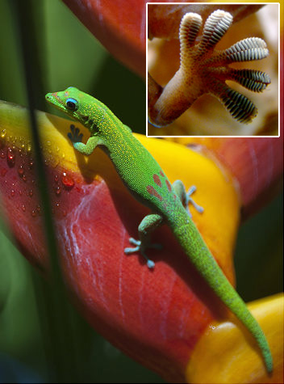 | 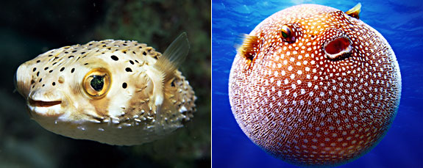
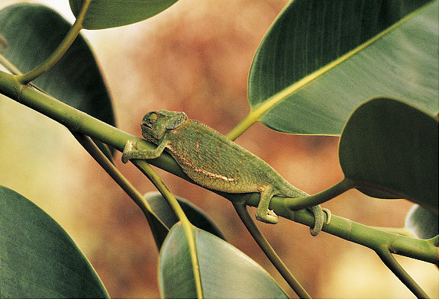 | 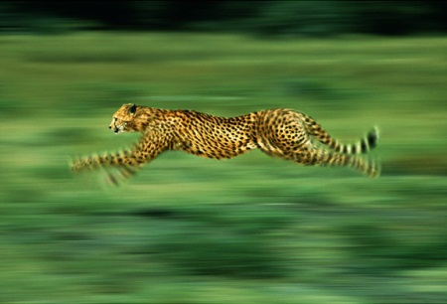 | 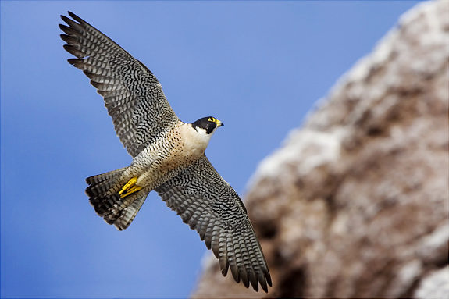
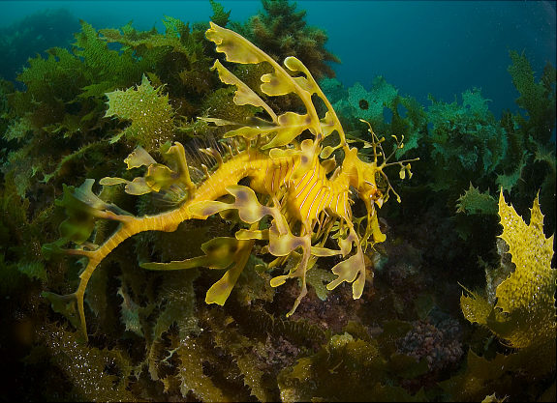 | 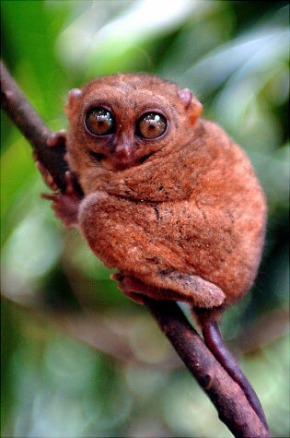 | 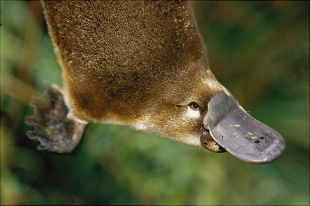
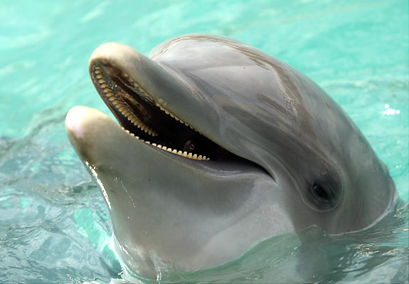 | 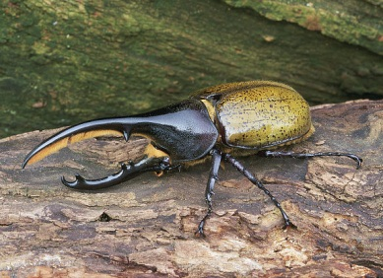 | 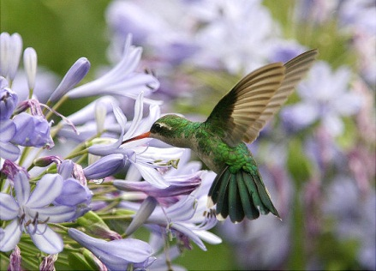
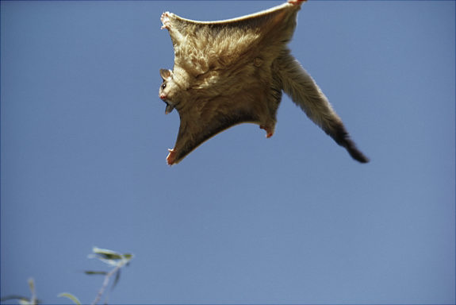 | 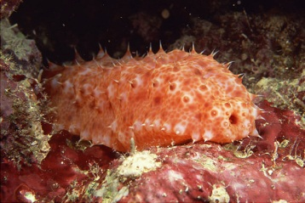 | 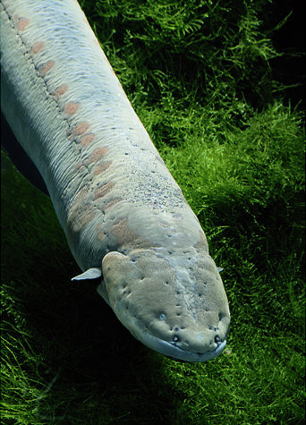
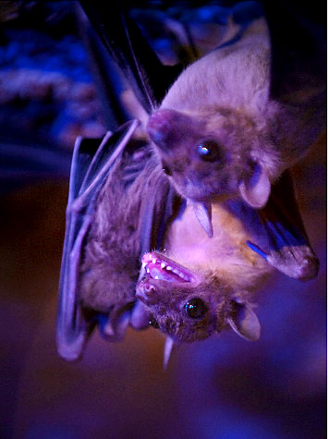

1  * | OCTOPUS: Shape-shifting, invisibility  This deep sea shape-shifter has eight tentacles and hides from predators. Its powers of camouflage make it almost invisible.  It can also spit out a cloud of ink in its enemies’ faces. The octopus can squeeze through narrow cracks and if one of its arms is pulled off, it can grow a new one later. Bottom line – don't mess with it.
2 | GECKO: Anti-gravity glue grip feet  The gecko has many special powers. It has its own language and can drop off its own tail should a predator latch on. The tiny lizard can also fling its poo at enemies. But the gecko's most famous super power is suction toes that let it easily climb up vertical walls and even across ceilings.
3 | PUFFERFISH: Inflatability, deadly poison  Don't be fooled by its cute face. The pufferfish may not be fast or flexible, but the fish has the amazing skill of growing in size to intimidate predators. The fish inflates by gulping water and air to change into a ball. Pufferfish, is also highly poisonous one fish holds enough poison to kill 30 adult humans.
4 | CHAMELEON: Invisibility  Chameleons can make a quick change to hues of brown, black, gold, green and even pink or turquoise. This special ability to blend in makes these lizards very hard for predators to see. Chameleons are also really good climbers and have very good eye sight.
5 | CHEETAH: Speed on land  This cool cat is the fastest land mammal on earth, with the ability to go from 0 to 60 mph in just 3 seconds. Its speed and its razor-sharp eyesight, let cheetah rule the grasslands where it lives hunting for prey -- and earn it the status of super beast
6 | PEREGRINE FALCON: Speed in air  Faster than a speeding bullet - you bet! With a razor sharp beak and talons, peregrine falcons are the fastest-flying birds on earth. They bring death from above to their prey at speeds of up to 200 mph
7 | SEA DRAGON: Camouflage  To hungry predators, it's almost impossible to pick out the well-disguised sea dragon from the plants in which it lives. The sea dragon has some of nature's best camouflage.
8 | TARSIER: Night vision  These huge eyes see everything. The tasier's eyeballs are each as big as its brain and allow the tiny nocturnal creature to hunt by night. The minuscule creature also has excellent hearing, thanks to its huge ears – and is able to swivel its head around in either direction to find its prey.

9 | PLATYPUS: Electroreception!  The web-footed creature has an amazing sixth sense: electoreception which lets it find its prey by sensing muscle movement. Even in a dark room wearing a blindfold and ear plugs, the platypus will hunt you down. They also have sharp talons on their heels that give a toxic kick to predators.
10 | DOLPHINS: Ultrasonic hearing  Dolphins have super hearing and can hear sounds at least ten times above what most humans hear and, they hear with their teeth! Dolphin teeth work like well-tuned antenna and act like an internal SAT-NAV
11 | RHINOCEROS BEETLE: Amazing strength  The Rhinoceros Beetle is thought to be one of the world’s strongest creatures and can carry up to 850 times its own body weight. A human would have to lift about 65 tons to match the minuscule bug's might. The beetle has a fierce horn – and it's not just for show, male beetles use them to joust – may the best beetle win!
12 | HUMMINGBIRD: Helicopter hover flight  Hummingbirds have wings that beat so fast – up to 90 times per second – that they can hover in mid-air. They’re also the only birds in the animal kingdom that can fly backwards. How do they get so much energy for their skills? Their diet consists of super-sweet nectar, which they must consume about every 10 minutes.
13 | FLYING SQUIRREL: It flies!  For these tree-living rodents, the sky’s really the limit. Flying squirrels don’t really fly – they glide from tree to tree. These amazing rodents have been known to glide for over 200 feet before landing. They stretch tight a webbed parachute-like membrane which keeps them in the air and their tail acts as a brake.
14 | SEA CUCUMBER: Body liquefication  When the sea cucumber senses danger, it melts! These oblong creatures are able to loosen or tighten their outer body armour whenever they need to – allowing them to squeeze through tiny cracks to escape from predators.
15 | ELECTRIC EEL: Zaps adversaries with electric shocks  . The electric eel uses its current to paralyse its prey. These shocks aren’t just tiny tingles either. An electric eel is capable of producing a 500 volt shock – enough to kill an adult human. They also use these shocks to protect themselves from predators
16 | BATS: Echolocation, hyper-healing  Bats have an echolocation power that allows them to work out the layout of a pitch black room and to locate hidden prey. The bat’s wings are very thin – allowing for sharp moves .

strong | kind | clever
rich | brave | Honest
responsible | funny | has super-powers
happy | proud | loyal
tall | thoughtful | shy
secret identity | hard working | determined

strong | kind | clever
rich | brave | honest
determined | secret identity | has super-powers

Notes:

We have been doing a cross-curricular project on superheroes in my year 5 class. In literacy, we have been looking at vocab and dictionary skills before we invented our own superhero. I used the pyramid sheet for paired work discussing the qualities with talk partners and then arranging those qualities on the pyramid in order of importance. The pictures and words I gave to the children to choose their top 3 super animals, and then locate the highlighted words in the dictionary to find a definition.

